RELATÓRIO DO TESTE

Cadastro de Registro de Óbito – Cenário 1: Preenchimento completo e salvamento.

Data do teste: 05/08/2025 17:25:33

🔄 Acessando sistema...

✅ Acessando sistema realizada com sucesso.

Screenshot: acessando_sistema

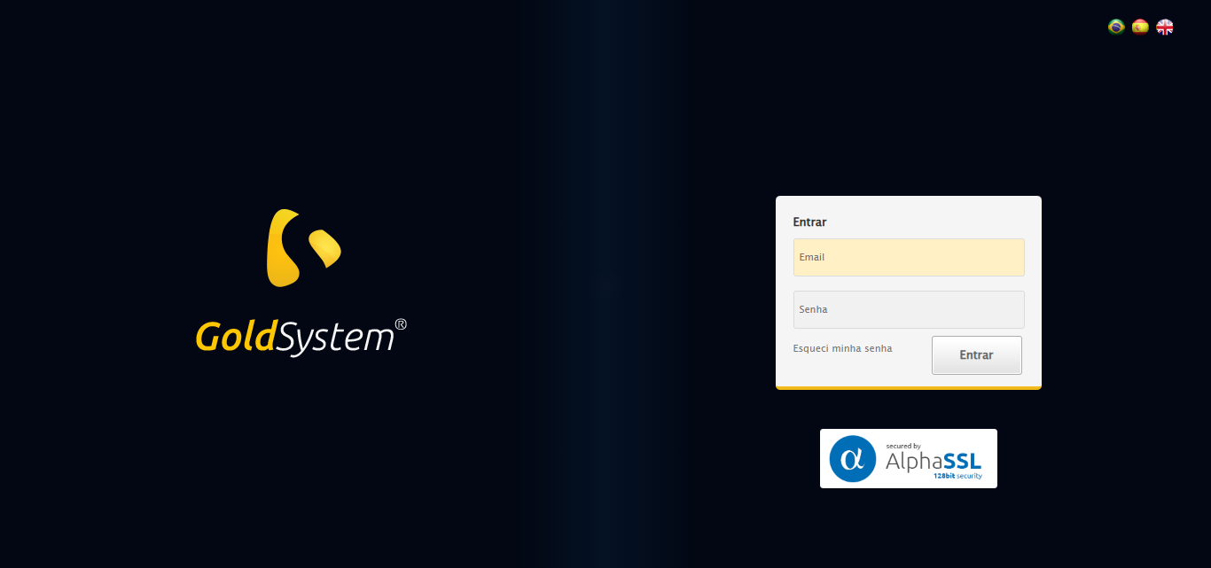

🔄 Realizando login...

✅ Realizando login realizada com sucesso.

Screenshot: realizando_login

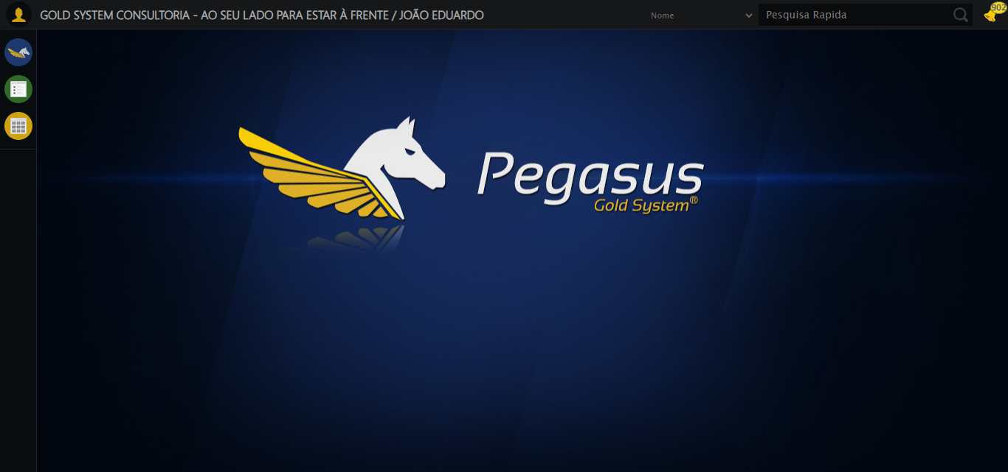

🔄 Ajustando zoom e abrindo menu...

🔍 Zoom ajustado para 90%.

✅ Ajustando zoom e abrindo menu realizada com sucesso.

Screenshot: ajustando_zoom_e_abrindo_menu

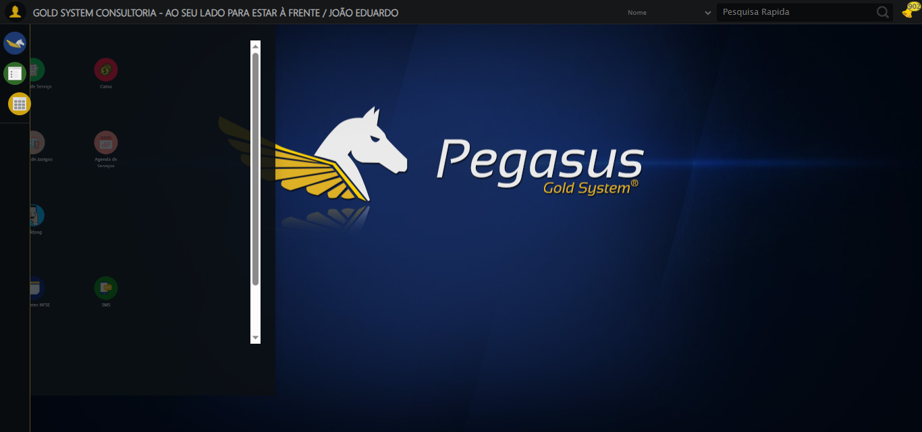

🔄 Acessando Registro de Óbito...

✅ Acessando Registro de Óbito realizada com sucesso.

Screenshot: acessando_registro_de_óbito

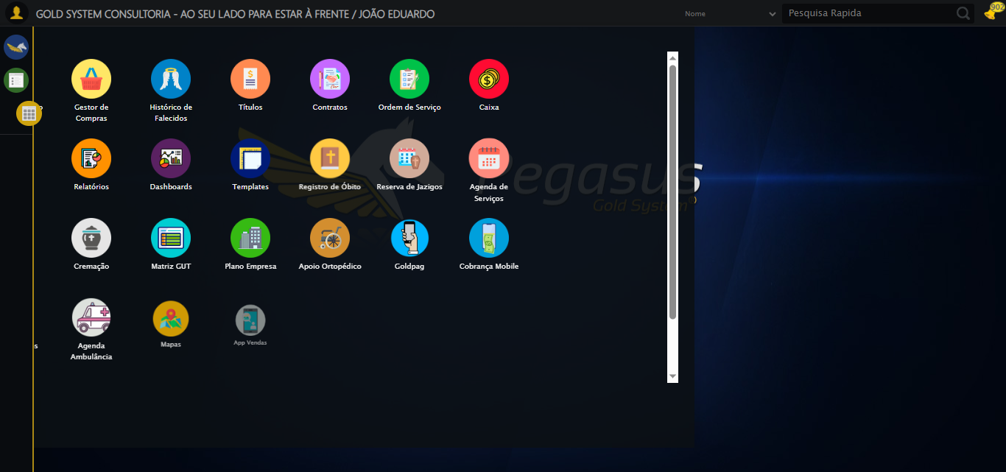

🔄 Clicando em Cadastrar...

✅ Clicando em Cadastrar realizada com sucesso.

Screenshot: clicando_em_cadastrar

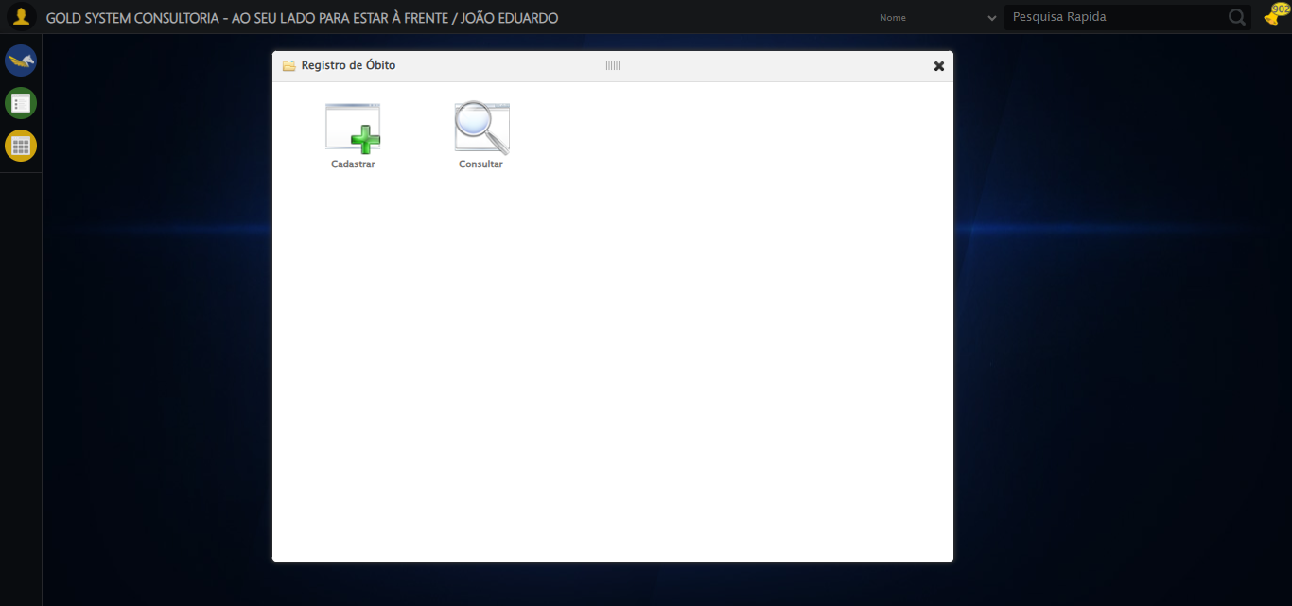

🔄 Selecionando Cartório...

✅ Selecionando Cartório realizada com sucesso.

Screenshot: selecionando_cartório

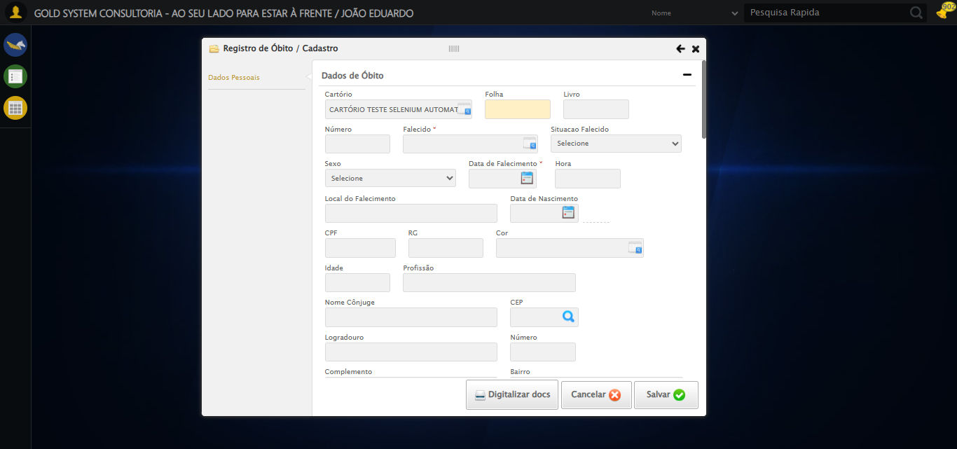

🔄 Preenchendo informações do registro...

✅ Preenchendo informações do registro realizada com sucesso.

Screenshot: preenchendo_informações_do_registro

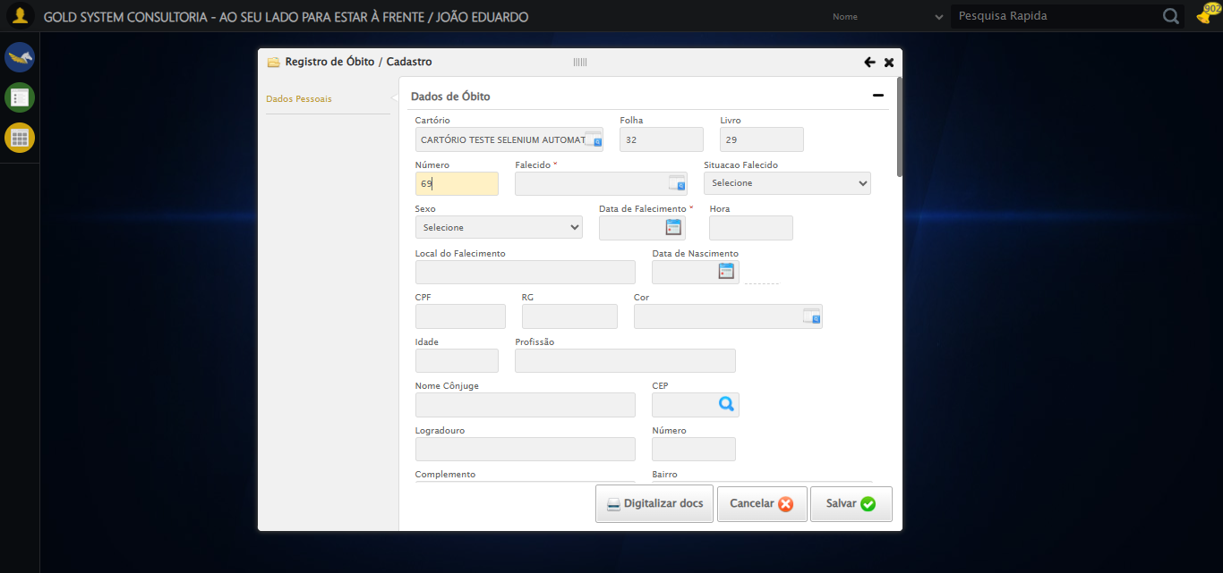

🔄 Selecionando pessoa falecida...

✅ Selecionando pessoa falecida realizada com sucesso.

Screenshot: selecionando_pessoa_falecida

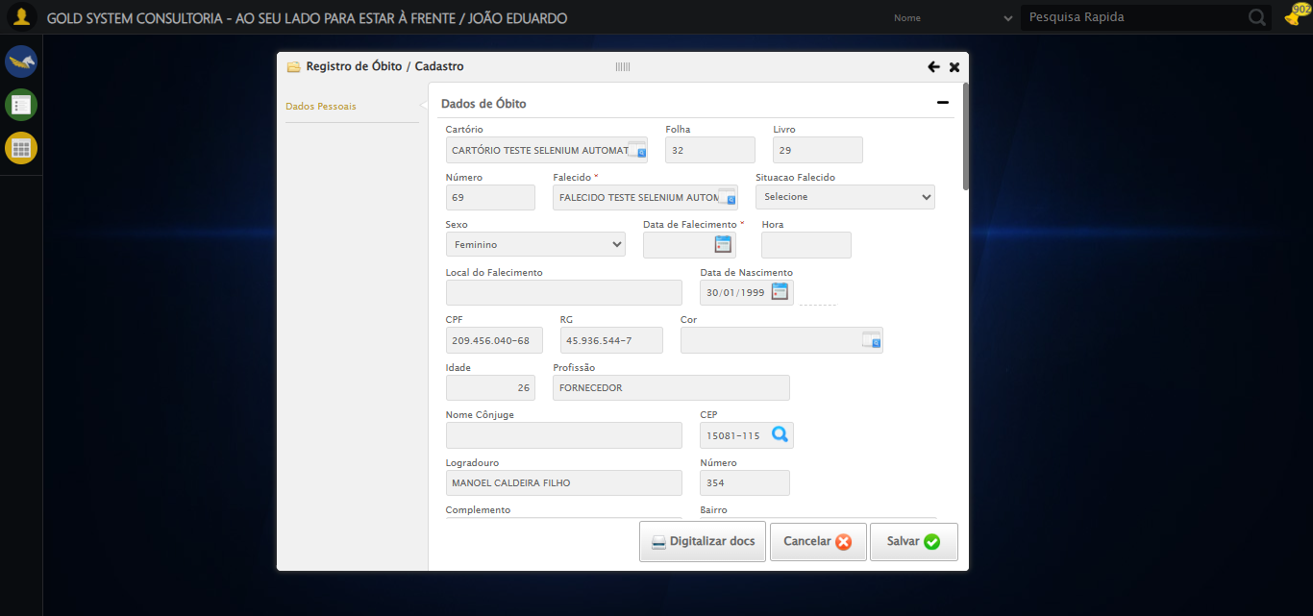

🔄 Selecionando Situação do Falecido...

✅ Selecionando Situação do Falecido realizada com sucesso.

Screenshot: selecionando_situação_do_falecido

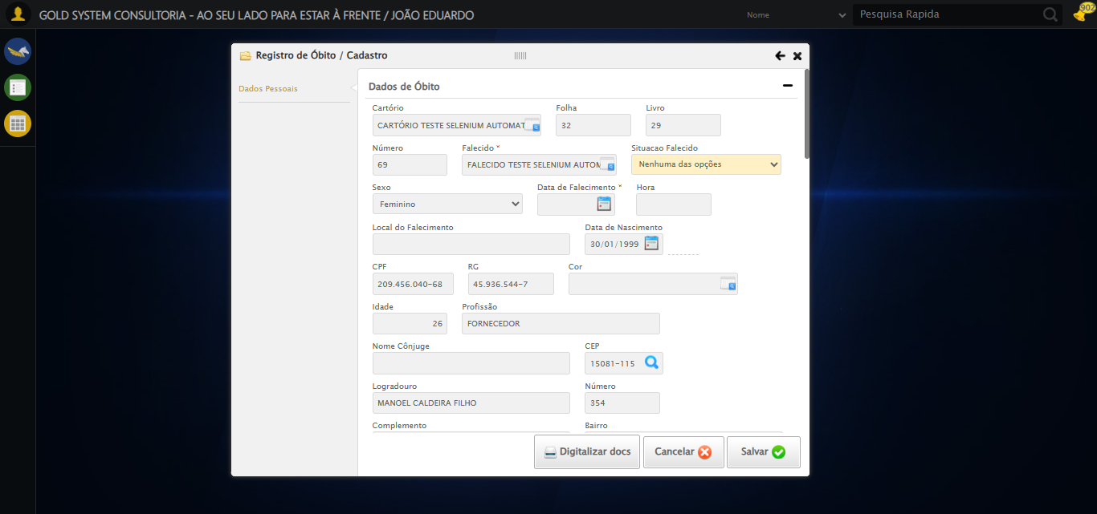

🔄 Selecionando sexo da pessoa falecida...

✅ Selecionando sexo da pessoa falecida realizada com sucesso.

Screenshot: selecionando_sexo_da_pessoa_falecida

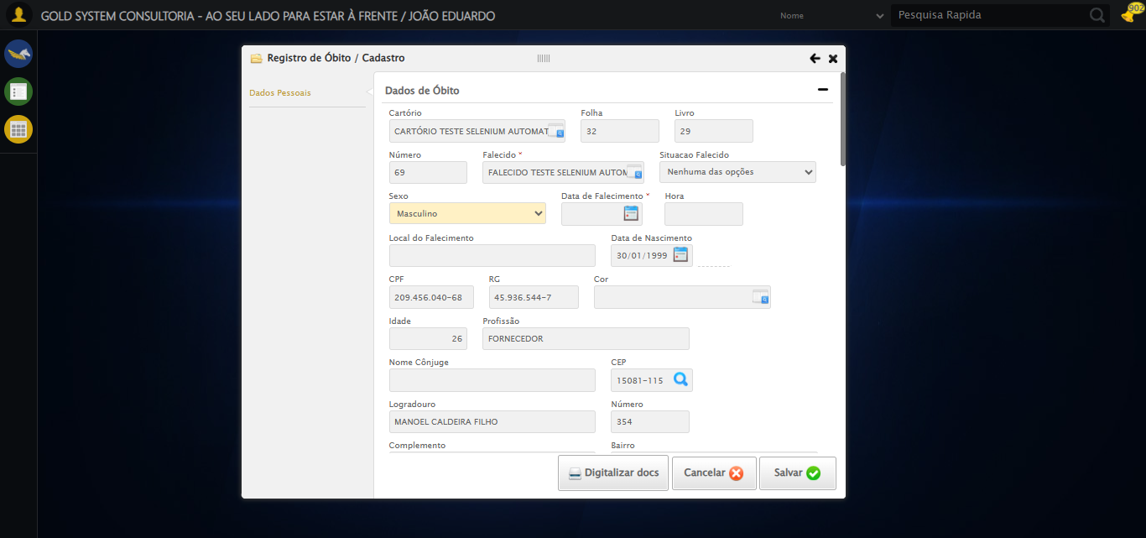

🔄 Preenchendo data e hora do falecimento...

Tentando seletor 1 para Data do Falecimento: //input[@grupo='10036' and @ref='25']

⚠️ Valor não foi definido corretamente no seletor 1

Tentando seletor 2 para Data do Falecimento: input[grupo='10036'][ref='25']

⚠️ Seletor 2 falhou para Data do Falecimento: Message: element click intercepted: Element <input type="text" grupo="10036" maxlength="10" id="dp1754425541567" class="hasDatepicker mandatory fc" ref="25" style="width: 90px;"> is not clickable at point (717, 255). Other element would receive the click: <select class="ui-datepicker-year" data-handler="selectYear" data-event="change">...</select>  
 (Session info: chrome=138.0.7204.184)  
Stacktrace:  
 GetHandleVerifier [0x0x30ba83+63395]  
 GetHandleVerifier [0x0x30bac4+63460]  
 (No symbol) [0x0x152113]  
 (No symbol) [0x0x1a0ba0]  
 (No symbol) [0x0x19ef5a]  
 (No symbol) [0x0x19cab7]  
 (No symbol) [0x0x19bd6d]  
 (No symbol) [0x0x190515]  
 (No symbol) [0x0x1bf3ac]  
 (No symbol) [0x0x18ffa4]  
 (No symbol) [0x0x1bf624]  
 (No symbol) [0x0x1e07ba]  
 (No symbol) [0x0x1bf1a6]  
 (No symbol) [0x0x18e7b2]  
 (No symbol) [0x0x18f654]  
 GetHandleVerifier [0x0x588883+2672035]  
 GetHandleVerifier [0x0x583cba+2652634]  
 GetHandleVerifier [0x0x332bca+223466]  
 GetHandleVerifier [0x0x322cb8+158168]  
 GetHandleVerifier [0x0x32978d+185517]  
 GetHandleVerifier [0x0x313b78+96408]  
 GetHandleVerifier [0x0x313d02+96802]  
 GetHandleVerifier [0x0x2fe90a+9770]  
 BaseThreadInitThunk [0x0x773dfcc9+25]  
 RtlGetAppContainerNamedObjectPath [0x0x77ba82ae+286]  
 RtlGetAppContainerNamedObjectPath [0x0x77ba827e+238]  
 (No symbol) [0x0]

Tentando seletor 3 para Data do Falecimento: #fmod_23 input.hasDatepicker.mandatory.fc[grupo='10036']

⚠️ Seletor 3 falhou para Data do Falecimento: Message: element click intercepted: Element <input type="text" grupo="10036" maxlength="10" id="dp1754425541567" class="hasDatepicker mandatory fc" ref="25" style="width: 90px;"> is not clickable at point (717, 255). Other element would receive the click: <select class="ui-datepicker-year" data-handler="selectYear" data-event="change">...</select>  
 (Session info: chrome=138.0.7204.184)  
Stacktrace:  
 GetHandleVerifier [0x0x30ba83+63395]  
 GetHandleVerifier [0x0x30bac4+63460]  
 (No symbol) [0x0x152113]  
 (No symbol) [0x0x1a0ba0]  
 (No symbol) [0x0x19ef5a]  
 (No symbol) [0x0x19cab7]  
 (No symbol) [0x0x19bd6d]  
 (No symbol) [0x0x190515]  
 (No symbol) [0x0x1bf3ac]  
 (No symbol) [0x0x18ffa4]  
 (No symbol) [0x0x1bf624]  
 (No symbol) [0x0x1e07ba]  
 (No symbol) [0x0x1bf1a6]  
 (No symbol) [0x0x18e7b2]  
 (No symbol) [0x0x18f654]  
 GetHandleVerifier [0x0x588883+2672035]  
 GetHandleVerifier [0x0x583cba+2652634]  
 GetHandleVerifier [0x0x332bca+223466]  
 GetHandleVerifier [0x0x322cb8+158168]  
 GetHandleVerifier [0x0x32978d+185517]  
 GetHandleVerifier [0x0x313b78+96408]  
 GetHandleVerifier [0x0x313d02+96802]  
 GetHandleVerifier [0x0x2fe90a+9770]  
 BaseThreadInitThunk [0x0x773dfcc9+25]  
 RtlGetAppContainerNamedObjectPath [0x0x77ba82ae+286]  
 RtlGetAppContainerNamedObjectPath [0x0x77ba827e+238]  
 (No symbol) [0x0]

Tentando seletor 4 para Data do Falecimento: //input[contains(@class, 'hasDatepicker') and contains(@class, 'mandatory') and @grupo='10036' and @ref='25']

⚠️ Seletor 4 falhou para Data do Falecimento: Message: element click intercepted: Element <input type="text" grupo="10036" maxlength="10" id="dp1754425541567" class="hasDatepicker mandatory fc" ref="25" style="width: 90px;"> is not clickable at point (717, 255). Other element would receive the click: <select class="ui-datepicker-year" data-handler="selectYear" data-event="change">...</select>  
 (Session info: chrome=138.0.7204.184)  
Stacktrace:  
 GetHandleVerifier [0x0x30ba83+63395]  
 GetHandleVerifier [0x0x30bac4+63460]  
 (No symbol) [0x0x152113]  
 (No symbol) [0x0x1a0ba0]  
 (No symbol) [0x0x19ef5a]  
 (No symbol) [0x0x19cab7]  
 (No symbol) [0x0x19bd6d]  
 (No symbol) [0x0x190515]  
 (No symbol) [0x0x1bf3ac]  
 (No symbol) [0x0x18ffa4]  
 (No symbol) [0x0x1bf624]  
 (No symbol) [0x0x1e07ba]  
 (No symbol) [0x0x1bf1a6]  
 (No symbol) [0x0x18e7b2]  
 (No symbol) [0x0x18f654]  
 GetHandleVerifier [0x0x588883+2672035]  
 GetHandleVerifier [0x0x583cba+2652634]  
 GetHandleVerifier [0x0x332bca+223466]  
 GetHandleVerifier [0x0x322cb8+158168]  
 GetHandleVerifier [0x0x32978d+185517]  
 GetHandleVerifier [0x0x313b78+96408]  
 GetHandleVerifier [0x0x313d02+96802]  
 GetHandleVerifier [0x0x2fe90a+9770]  
 BaseThreadInitThunk [0x0x773dfcc9+25]  
 RtlGetAppContainerNamedObjectPath [0x0x77ba82ae+286]  
 RtlGetAppContainerNamedObjectPath [0x0x77ba827e+238]  
 (No symbol) [0x0]

❌ Erro inesperado ao preenchendo data e hora do falecimento: Todos os seletores falharam para Data do Falecimento. Último erro: Message: element click intercepted: Element <input type="text" grupo="10036" maxlength="10" id="dp1754425541567" class="hasDatepicker mandatory fc" ref="25" style="width: 90px;"> is not clickable at point (717, 255). Other element would receive the click: <select class="ui-datepicker-year" data-handler="selectYear" data-event="change">...</select>  
 (Session info: chrome=138.0.7204.184)  
Stacktrace:  
 GetHandleVerifier [0x0x30ba83+63395]  
 GetHandleVerifier [0x0x30bac4+63460]  
 (No symbol) [0x0x152113]  
 (No symbol) [0x0x1a0ba0]  
 (No symbol) [0x0x19ef5a]  
 (No symbol) [0x0x19cab7]  
 (No symbol) [0x0x19bd6d]  
 (No symbol) [0x0x190515]  
 (No symbol) [0x0x1bf3ac]  
 (No symbol) [0x0x18ffa4]  
 (No symbol) [0x0x1bf624]  
 (No symbol) [0x0x1e07ba]  
 (No symbol) [0x0x1bf1a6]  
 (No symbol) [0x0x18e7b2]  
 (No symbol) [0x0x18f654]  
 GetHandleVerifier [0x0x588883+2672035]  
 GetHandleVerifier [0x0x583cba+2652634]  
 GetHandleVerifier [0x0x332bca+223466]  
 GetHandleVerifier [0x0x322cb8+158168]  
 GetHandleVerifier [0x0x32978d+185517]  
 GetHandleVerifier [0x0x313b78+96408]  
 GetHandleVerifier [0x0x313d02+96802]  
 GetHandleVerifier [0x0x2fe90a+9770]  
 BaseThreadInitThunk [0x0x773dfcc9+25]  
 RtlGetAppContainerNamedObjectPath [0x0x77ba82ae+286]  
 RtlGetAppContainerNamedObjectPath [0x0x77ba827e+238]  
 (No symbol) [0x0]

Screenshot: erro_preenchendo_data_e_hora_do_falecimento

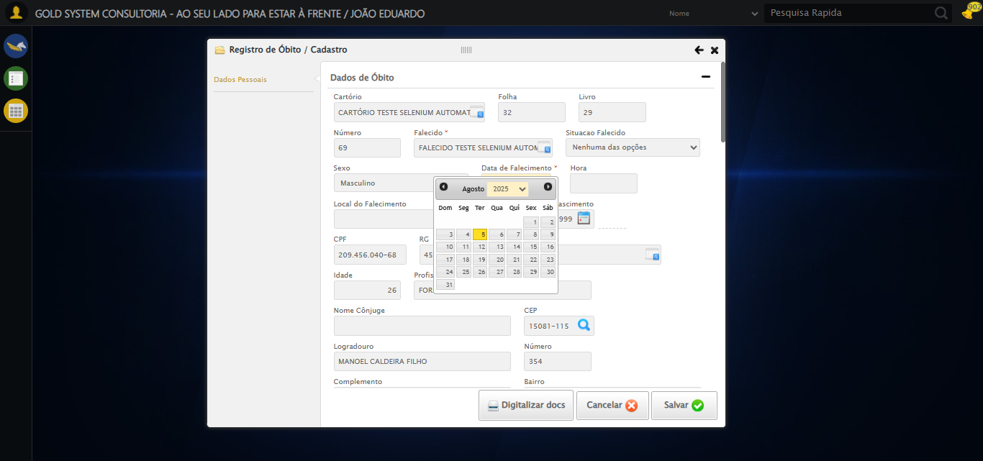

🔄 Preenchendo Local de Falecimento...

✅ Preenchendo Local de Falecimento realizada com sucesso.

Screenshot: preenchendo_local_de_falecimento

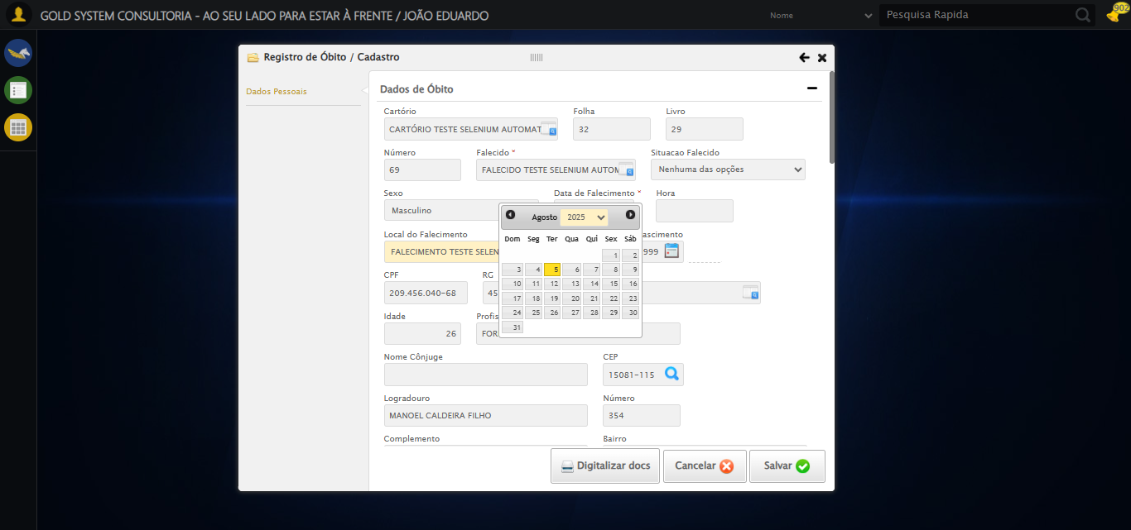

🔄 Selecionando Cor da pessoa falecida...

✅ Selecionando Cor da pessoa falecida realizada com sucesso.

Screenshot: selecionando_cor_da_pessoa_falecida

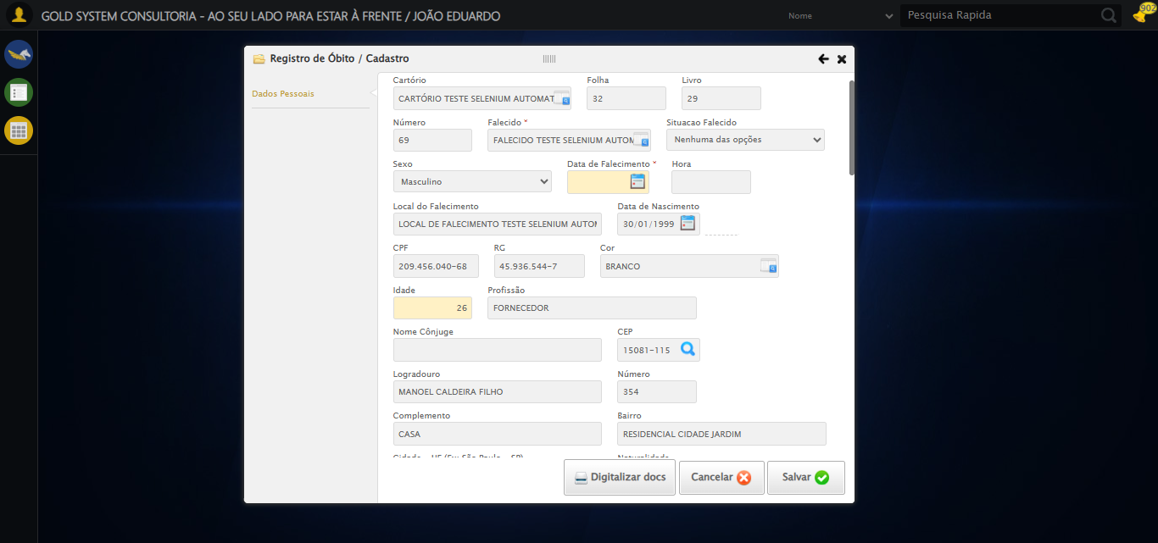

🔄 Preenchendo Nome do Cônjuge...

✅ Preenchendo Nome do Cônjuge realizada com sucesso.

Screenshot: preenchendo_nome_do_cônjuge

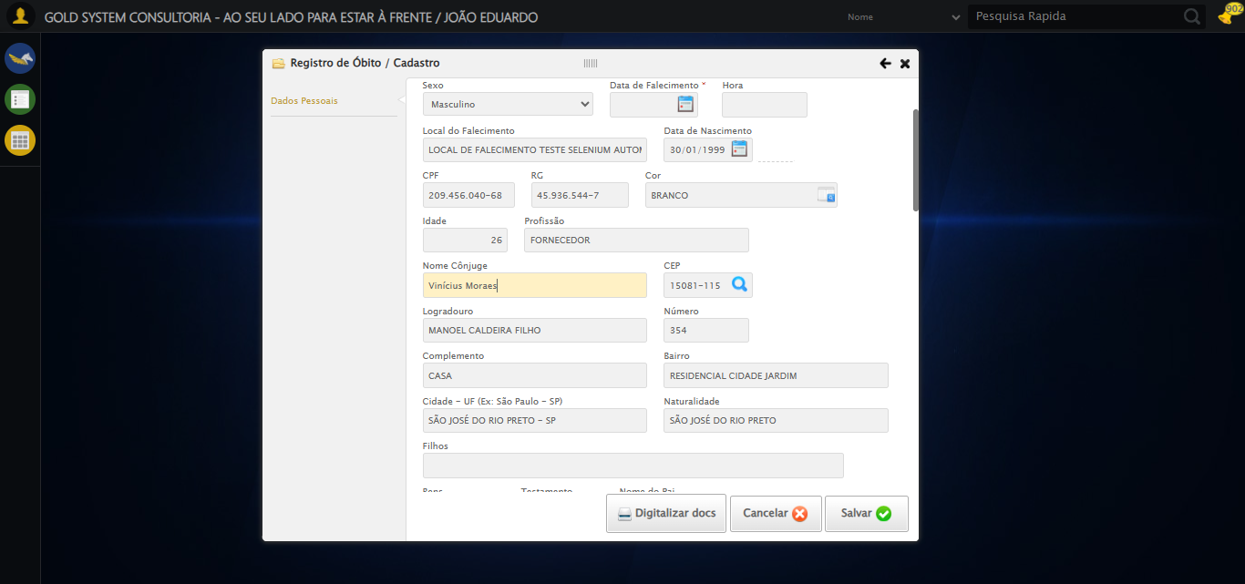

🔄 Preenchendo Nome do Filho...

✅ Preenchendo Nome do Filho realizada com sucesso.

Screenshot: preenchendo_nome_do_filho

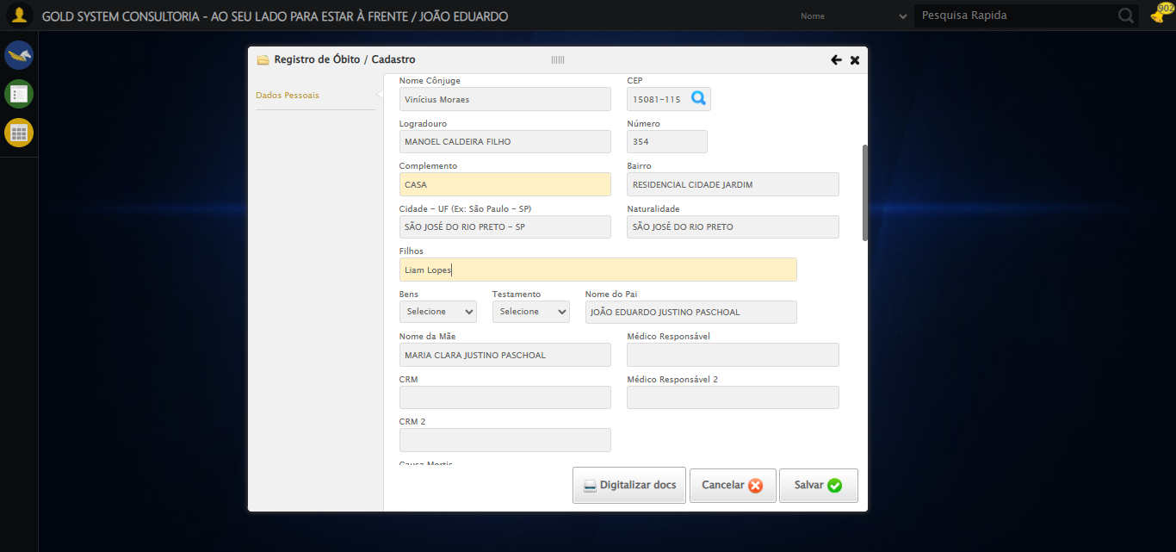

🔄 Selecionando a opção para o Falecido possuir Bens...

✅ Selecionando a opção para o Falecido possuir Bens realizada com sucesso.

Screenshot: selecionando_a_opção_para_o_falecido_possuir_bens

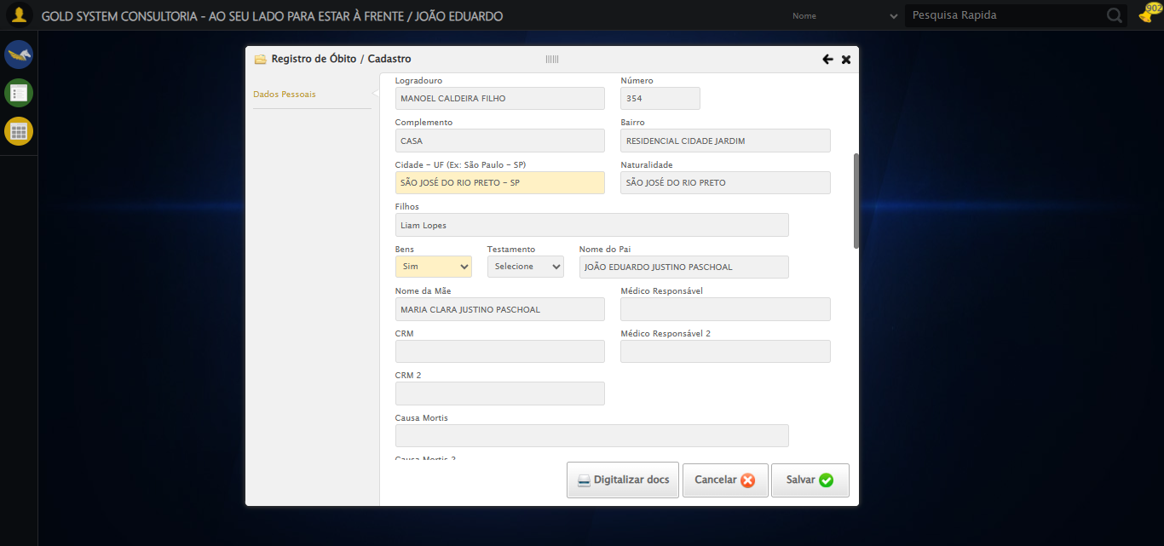

🔄 Selecionando a opção para o Falecido possuir Testamento...

✅ Selecionando a opção para o Falecido possuir Testamento realizada com sucesso.

Screenshot: selecionando_a_opção_para_o_falecido_possuir_testamento

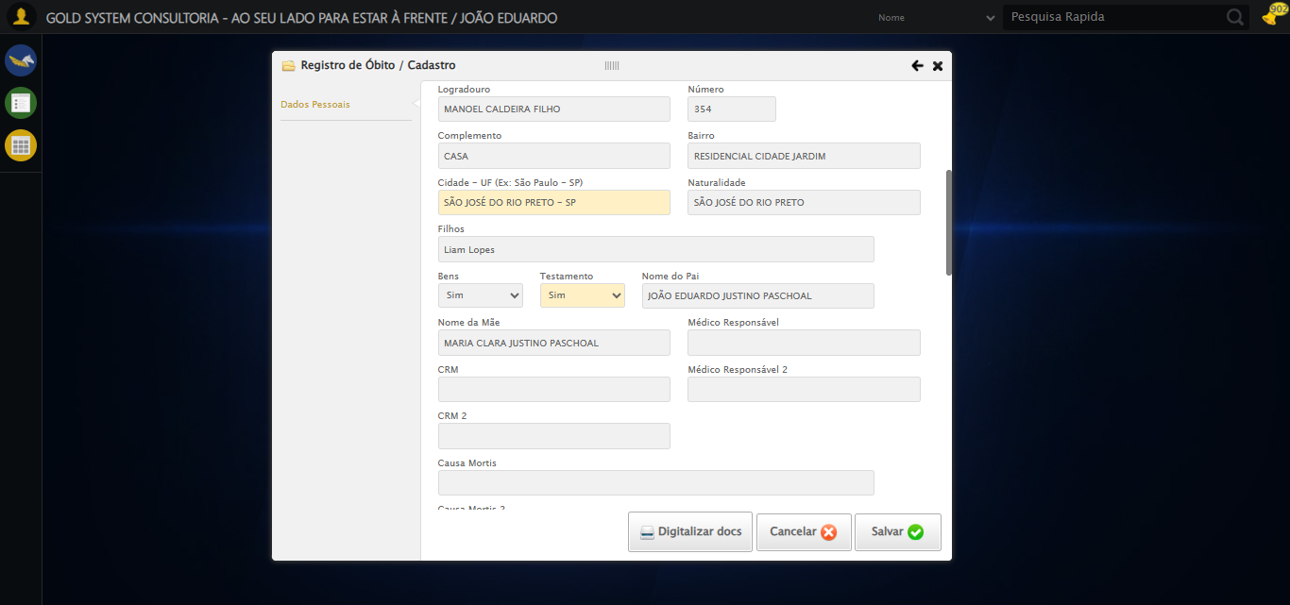

🔄 Preenchendo Nome do Médico Responsável...

✅ Preenchendo Nome do Médico Responsável realizada com sucesso.

Screenshot: preenchendo_nome_do_médico_responsável

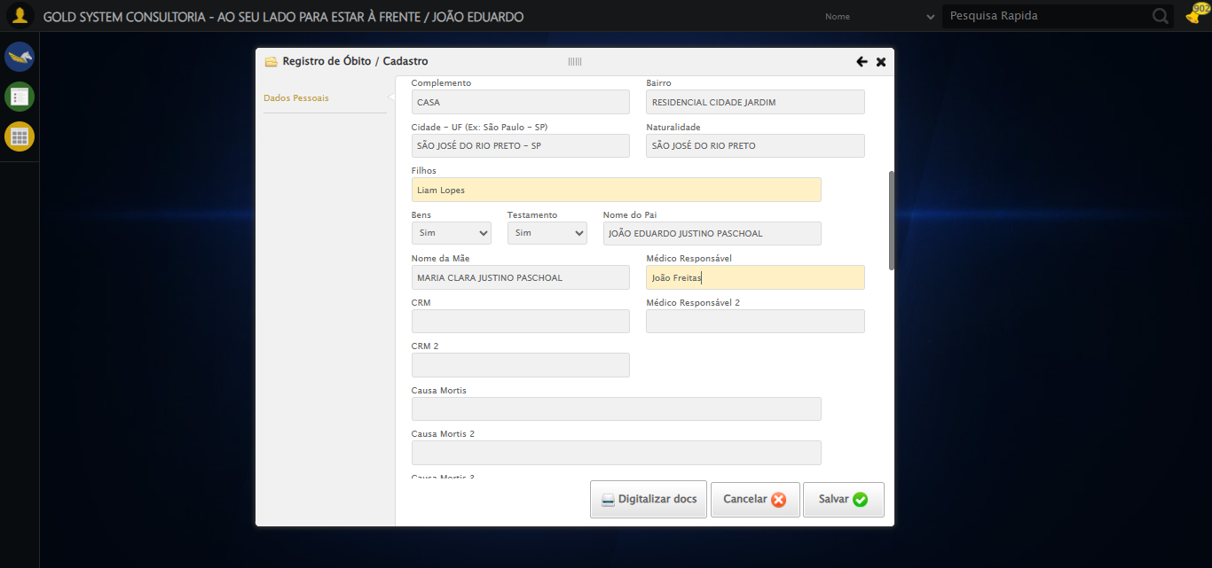

🔄 Preenchendo CRM...

✅ Preenchendo CRM realizada com sucesso.

Screenshot: preenchendo_crm

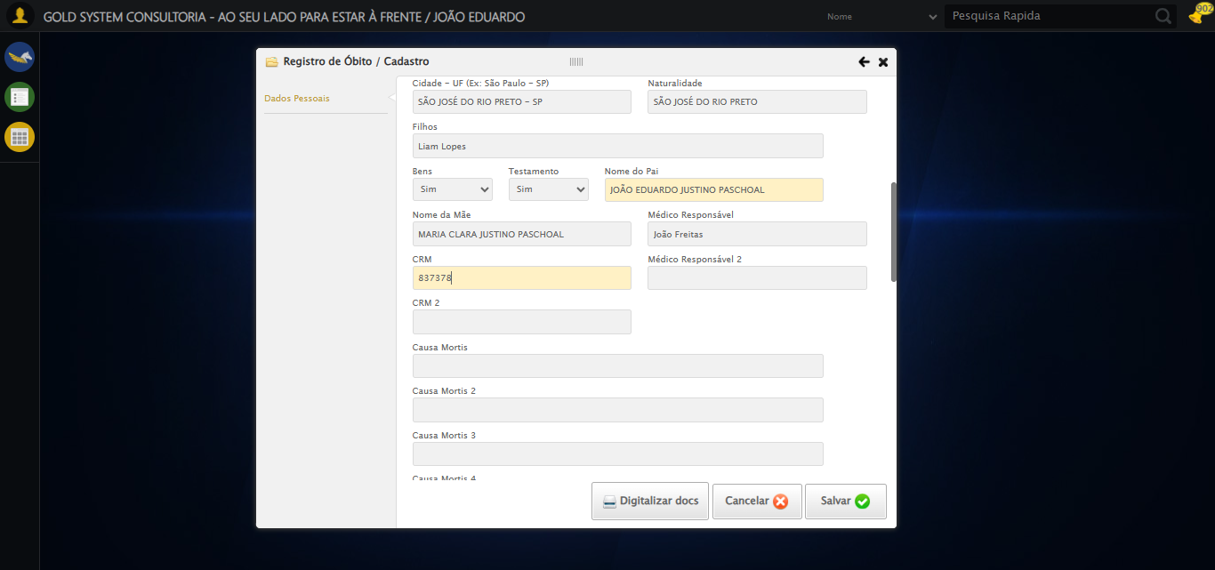

🔄 Preenchendo Nome do Médico Responsável 2...

✅ Preenchendo Nome do Médico Responsável 2 realizada com sucesso.

Screenshot: preenchendo_nome_do_médico_responsável_2

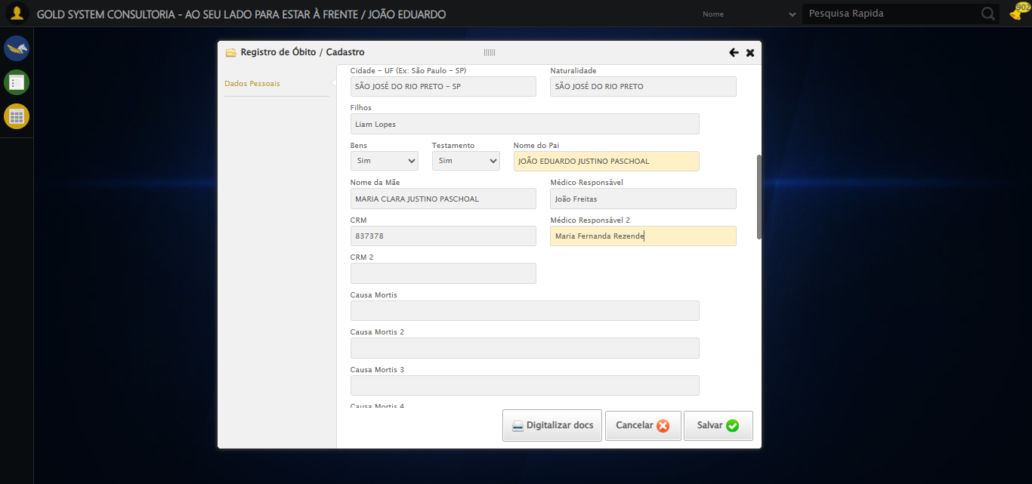

🔄 Preenchendo CRM 2...

✅ Preenchendo CRM 2 realizada com sucesso.

Screenshot: preenchendo_crm_2

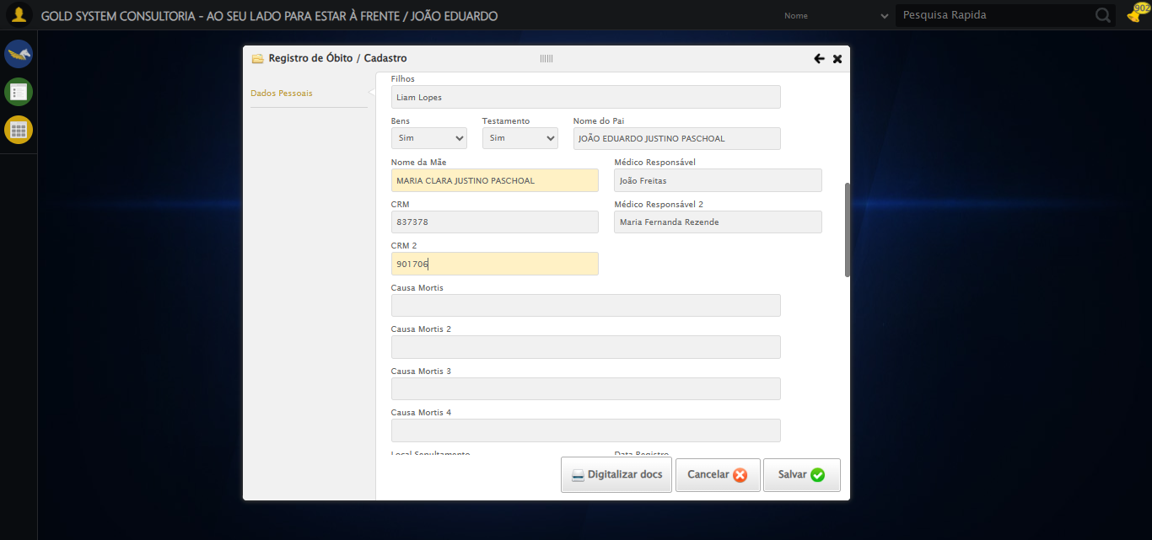

🔄 Preenchendo Causa Mortis...

✅ Preenchendo Causa Mortis realizada com sucesso.

Screenshot: preenchendo_causa_mortis

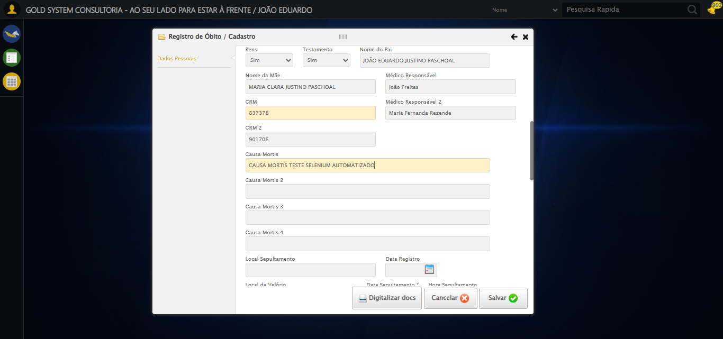

🔄 Preenchendo Causa Mortis 2...

✅ Preenchendo Causa Mortis 2 realizada com sucesso.

Screenshot: preenchendo_causa_mortis_2

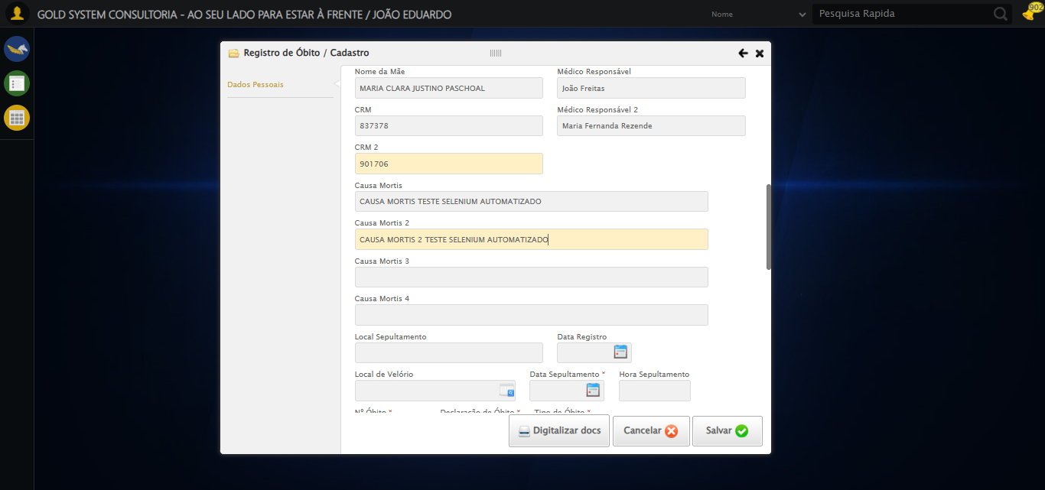

🔄 Preenchendo Causa Mortis 3...

✅ Preenchendo Causa Mortis 3 realizada com sucesso.

Screenshot: preenchendo_causa_mortis_3

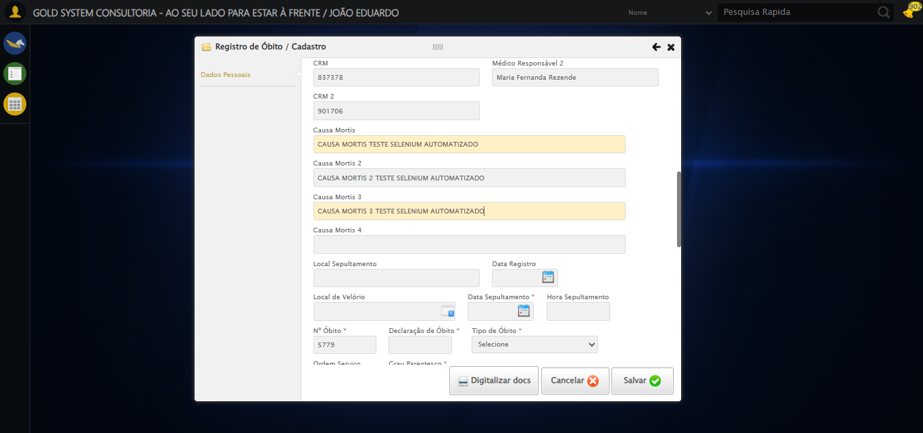

🔄 Preenchendo Causa Mortis 4...

✅ Preenchendo Causa Mortis 4 realizada com sucesso.

Screenshot: preenchendo_causa_mortis_4

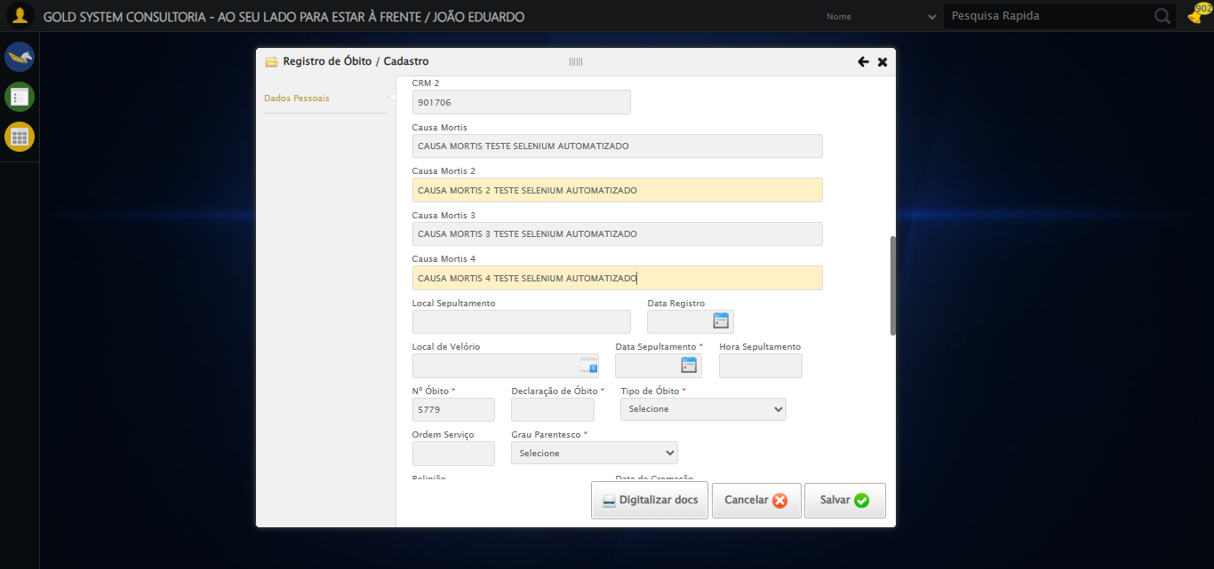

🔄 Preenchendo Local Sepultamento...

✅ Preenchendo Local Sepultamento realizada com sucesso.

Screenshot: preenchendo_local_sepultamento

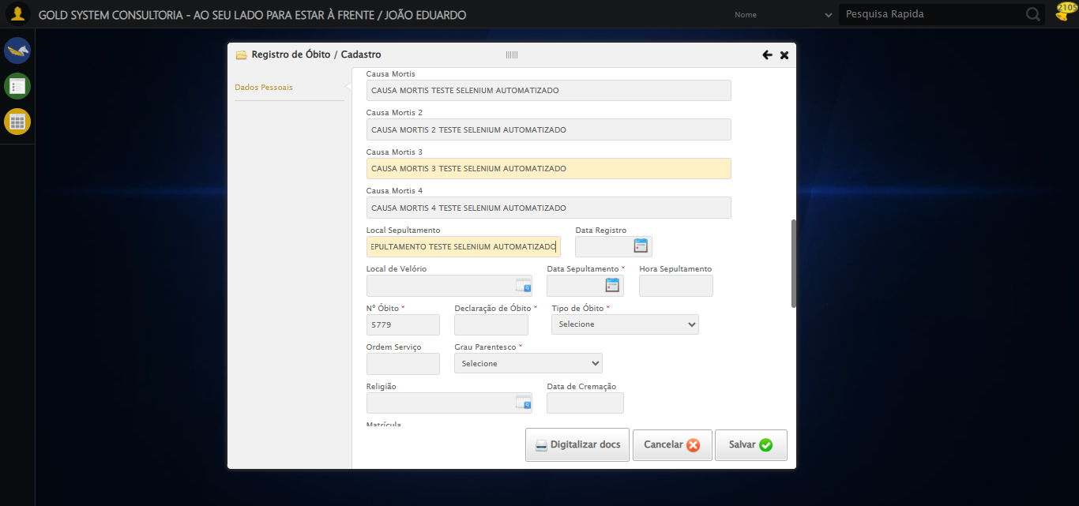

🔄 Preenchendo Data Registro...

Tentando seletor 1 para Data do Registro: //input[@grupo='10036' and @ref='10118']

⚠️ Valor não foi definido corretamente no seletor 1

Tentando seletor 2 para Data do Registro: input[grupo='10036'][ref='10118']

⚠️ Seletor 2 falhou para Data do Registro: Message: element click intercepted: Element <input type="text" grupo="10036" maxlength="10" id="dp1754425541570" class="hasDatepicker fc" ref="10118" style="width: 90px;"> is not clickable at point (777, 312). Other element would receive the click: <select class="ui-datepicker-year" data-handler="selectYear" data-event="change">...</select>  
 (Session info: chrome=138.0.7204.184)  
Stacktrace:  
 GetHandleVerifier [0x0x30ba83+63395]  
 GetHandleVerifier [0x0x30bac4+63460]  
 (No symbol) [0x0x152113]  
 (No symbol) [0x0x1a0ba0]  
 (No symbol) [0x0x19ef5a]  
 (No symbol) [0x0x19cab7]  
 (No symbol) [0x0x19bd6d]  
 (No symbol) [0x0x190515]  
 (No symbol) [0x0x1bf3ac]  
 (No symbol) [0x0x18ffa4]  
 (No symbol) [0x0x1bf624]  
 (No symbol) [0x0x1e07ba]  
 (No symbol) [0x0x1bf1a6]  
 (No symbol) [0x0x18e7b2]  
 (No symbol) [0x0x18f654]  
 GetHandleVerifier [0x0x588883+2672035]  
 GetHandleVerifier [0x0x583cba+2652634]  
 GetHandleVerifier [0x0x332bca+223466]  
 GetHandleVerifier [0x0x322cb8+158168]  
 GetHandleVerifier [0x0x32978d+185517]  
 GetHandleVerifier [0x0x313b78+96408]  
 GetHandleVerifier [0x0x313d02+96802]  
 GetHandleVerifier [0x0x2fe90a+9770]  
 BaseThreadInitThunk [0x0x773dfcc9+25]  
 RtlGetAppContainerNamedObjectPath [0x0x77ba82ae+286]  
 RtlGetAppContainerNamedObjectPath [0x0x77ba827e+238]  
 (No symbol) [0x0]

Tentando seletor 3 para Data do Registro: #fmod_23 input[grupo='10036'][ref='10118']

⚠️ Seletor 3 falhou para Data do Registro: Message: element click intercepted: Element <input type="text" grupo="10036" maxlength="10" id="dp1754425541570" class="hasDatepicker fc" ref="10118" style="width: 90px;"> is not clickable at point (777, 312). Other element would receive the click: <select class="ui-datepicker-year" data-handler="selectYear" data-event="change">...</select>  
 (Session info: chrome=138.0.7204.184)  
Stacktrace:  
 GetHandleVerifier [0x0x30ba83+63395]  
 GetHandleVerifier [0x0x30bac4+63460]  
 (No symbol) [0x0x152113]  
 (No symbol) [0x0x1a0ba0]  
 (No symbol) [0x0x19ef5a]  
 (No symbol) [0x0x19cab7]  
 (No symbol) [0x0x19bd6d]  
 (No symbol) [0x0x190515]  
 (No symbol) [0x0x1bf3ac]  
 (No symbol) [0x0x18ffa4]  
 (No symbol) [0x0x1bf624]  
 (No symbol) [0x0x1e07ba]  
 (No symbol) [0x0x1bf1a6]  
 (No symbol) [0x0x18e7b2]  
 (No symbol) [0x0x18f654]  
 GetHandleVerifier [0x0x588883+2672035]  
 GetHandleVerifier [0x0x583cba+2652634]  
 GetHandleVerifier [0x0x332bca+223466]  
 GetHandleVerifier [0x0x322cb8+158168]  
 GetHandleVerifier [0x0x32978d+185517]  
 GetHandleVerifier [0x0x313b78+96408]  
 GetHandleVerifier [0x0x313d02+96802]  
 GetHandleVerifier [0x0x2fe90a+9770]  
 BaseThreadInitThunk [0x0x773dfcc9+25]  
 RtlGetAppContainerNamedObjectPath [0x0x77ba82ae+286]  
 RtlGetAppContainerNamedObjectPath [0x0x77ba827e+238]  
 (No symbol) [0x0]

Tentando seletor 4 para Data do Registro: //input[contains(@class, 'hasDatepicker') and @grupo='10036' and @ref='10118']

⚠️ Seletor 4 falhou para Data do Registro: Message: element click intercepted: Element <input type="text" grupo="10036" maxlength="10" id="dp1754425541570" class="hasDatepicker fc" ref="10118" style="width: 90px;"> is not clickable at point (777, 312). Other element would receive the click: <select class="ui-datepicker-year" data-handler="selectYear" data-event="change">...</select>  
 (Session info: chrome=138.0.7204.184)  
Stacktrace:  
 GetHandleVerifier [0x0x30ba83+63395]  
 GetHandleVerifier [0x0x30bac4+63460]  
 (No symbol) [0x0x152113]  
 (No symbol) [0x0x1a0ba0]  
 (No symbol) [0x0x19ef5a]  
 (No symbol) [0x0x19cab7]  
 (No symbol) [0x0x19bd6d]  
 (No symbol) [0x0x190515]  
 (No symbol) [0x0x1bf3ac]  
 (No symbol) [0x0x18ffa4]  
 (No symbol) [0x0x1bf624]  
 (No symbol) [0x0x1e07ba]  
 (No symbol) [0x0x1bf1a6]  
 (No symbol) [0x0x18e7b2]  
 (No symbol) [0x0x18f654]  
 GetHandleVerifier [0x0x588883+2672035]  
 GetHandleVerifier [0x0x583cba+2652634]  
 GetHandleVerifier [0x0x332bca+223466]  
 GetHandleVerifier [0x0x322cb8+158168]  
 GetHandleVerifier [0x0x32978d+185517]  
 GetHandleVerifier [0x0x313b78+96408]  
 GetHandleVerifier [0x0x313d02+96802]  
 GetHandleVerifier [0x0x2fe90a+9770]  
 BaseThreadInitThunk [0x0x773dfcc9+25]  
 RtlGetAppContainerNamedObjectPath [0x0x77ba82ae+286]  
 RtlGetAppContainerNamedObjectPath [0x0x77ba827e+238]  
 (No symbol) [0x0]

❌ Erro inesperado ao preenchendo data registro: Todos os seletores falharam para Data do Registro. Último erro: Message: element click intercepted: Element <input type="text" grupo="10036" maxlength="10" id="dp1754425541570" class="hasDatepicker fc" ref="10118" style="width: 90px;"> is not clickable at point (777, 312). Other element would receive the click: <select class="ui-datepicker-year" data-handler="selectYear" data-event="change">...</select>  
 (Session info: chrome=138.0.7204.184)  
Stacktrace:  
 GetHandleVerifier [0x0x30ba83+63395]  
 GetHandleVerifier [0x0x30bac4+63460]  
 (No symbol) [0x0x152113]  
 (No symbol) [0x0x1a0ba0]  
 (No symbol) [0x0x19ef5a]  
 (No symbol) [0x0x19cab7]  
 (No symbol) [0x0x19bd6d]  
 (No symbol) [0x0x190515]  
 (No symbol) [0x0x1bf3ac]  
 (No symbol) [0x0x18ffa4]  
 (No symbol) [0x0x1bf624]  
 (No symbol) [0x0x1e07ba]  
 (No symbol) [0x0x1bf1a6]  
 (No symbol) [0x0x18e7b2]  
 (No symbol) [0x0x18f654]  
 GetHandleVerifier [0x0x588883+2672035]  
 GetHandleVerifier [0x0x583cba+2652634]  
 GetHandleVerifier [0x0x332bca+223466]  
 GetHandleVerifier [0x0x322cb8+158168]  
 GetHandleVerifier [0x0x32978d+185517]  
 GetHandleVerifier [0x0x313b78+96408]  
 GetHandleVerifier [0x0x313d02+96802]  
 GetHandleVerifier [0x0x2fe90a+9770]  
 BaseThreadInitThunk [0x0x773dfcc9+25]  
 RtlGetAppContainerNamedObjectPath [0x0x77ba82ae+286]  
 RtlGetAppContainerNamedObjectPath [0x0x77ba827e+238]  
 (No symbol) [0x0]

Screenshot: erro_preenchendo_data_registro

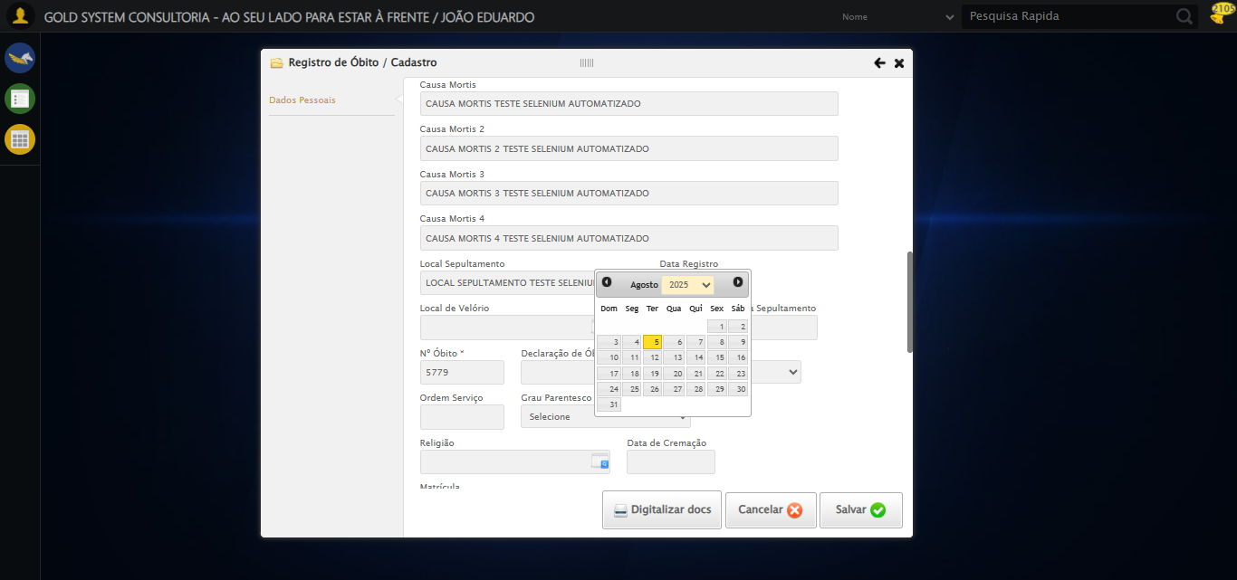

🔄 Selecionando Local de Velório...

❌ Erro ao interagir com elemento #fmod_23 > div.wdTelas > div.telaCadastro.clearfix > div.catWrapper > div > div > div:nth-child(1) > div > div:nth-child(41) > div > a: Message: element click intercepted: Element <a class="sprites sp-openLov"></a> is not clickable at point (661, 312). Other element would receive the click: <a class="ui-datepicker-prev ui-corner-all" data-handler="prev" data-event="click" title="<Anterior">...</a>  
 (Session info: chrome=138.0.7204.184)  
Stacktrace:  
 GetHandleVerifier [0x0x30ba83+63395]  
 GetHandleVerifier [0x0x30bac4+63460]  
 (No symbol) [0x0x152113]  
 (No symbol) [0x0x1a0ba0]  
 (No symbol) [0x0x19ef5a]  
 (No symbol) [0x0x19cab7]  
 (No symbol) [0x0x19bd6d]  
 (No symbol) [0x0x190515]  
 (No symbol) [0x0x1bf3ac]  
 (No symbol) [0x0x18ffa4]  
 (No symbol) [0x0x1bf624]  
 (No symbol) [0x0x1e07ba]  
 (No symbol) [0x0x1bf1a6]  
 (No symbol) [0x0x18e7b2]  
 (No symbol) [0x0x18f654]  
 GetHandleVerifier [0x0x588883+2672035]  
 GetHandleVerifier [0x0x583cba+2652634]  
 GetHandleVerifier [0x0x332bca+223466]  
 GetHandleVerifier [0x0x322cb8+158168]  
 GetHandleVerifier [0x0x32978d+185517]  
 GetHandleVerifier [0x0x313b78+96408]  
 GetHandleVerifier [0x0x313d02+96802]  
 GetHandleVerifier [0x0x2fe90a+9770]  
 BaseThreadInitThunk [0x0x773dfcc9+25]  
 RtlGetAppContainerNamedObjectPath [0x0x77ba82ae+286]  
 RtlGetAppContainerNamedObjectPath [0x0x77ba827e+238]  
 (No symbol) [0x0]

⚠️ Tentativa 1 falhou para Selecionando Local de Velório, tentando novamente...

🔄 Selecionando Local de Velório... (Tentativa 2)

❌ Erro ao interagir com elemento #fmod_23 > div.wdTelas > div.telaCadastro.clearfix > div.catWrapper > div > div > div:nth-child(1) > div > div:nth-child(41) > div > a: Message: element click intercepted: Element <a class="sprites sp-openLov"></a> is not clickable at point (661, 312). Other element would receive the click: <a class="ui-datepicker-prev ui-corner-all" data-handler="prev" data-event="click" title="<Anterior">...</a>  
 (Session info: chrome=138.0.7204.184)  
Stacktrace:  
 GetHandleVerifier [0x0x30ba83+63395]  
 GetHandleVerifier [0x0x30bac4+63460]  
 (No symbol) [0x0x152113]  
 (No symbol) [0x0x1a0ba0]  
 (No symbol) [0x0x19ef5a]  
 (No symbol) [0x0x19cab7]  
 (No symbol) [0x0x19bd6d]  
 (No symbol) [0x0x190515]  
 (No symbol) [0x0x1bf3ac]  
 (No symbol) [0x0x18ffa4]  
 (No symbol) [0x0x1bf624]  
 (No symbol) [0x0x1e07ba]  
 (No symbol) [0x0x1bf1a6]  
 (No symbol) [0x0x18e7b2]  
 (No symbol) [0x0x18f654]  
 GetHandleVerifier [0x0x588883+2672035]  
 GetHandleVerifier [0x0x583cba+2652634]  
 GetHandleVerifier [0x0x332bca+223466]  
 GetHandleVerifier [0x0x322cb8+158168]  
 GetHandleVerifier [0x0x32978d+185517]  
 GetHandleVerifier [0x0x313b78+96408]  
 GetHandleVerifier [0x0x313d02+96802]  
 GetHandleVerifier [0x0x2fe90a+9770]  
 BaseThreadInitThunk [0x0x773dfcc9+25]  
 RtlGetAppContainerNamedObjectPath [0x0x77ba82ae+286]  
 RtlGetAppContainerNamedObjectPath [0x0x77ba827e+238]  
 (No symbol) [0x0]

⚠️ Tentativa 2 falhou para Selecionando Local de Velório, tentando novamente...

🔄 Selecionando Local de Velório... (Tentativa 3)

❌ Erro ao interagir com elemento #fmod_23 > div.wdTelas > div.telaCadastro.clearfix > div.catWrapper > div > div > div:nth-child(1) > div > div:nth-child(41) > div > a: Message: element click intercepted: Element <a class="sprites sp-openLov"></a> is not clickable at point (661, 312). Other element would receive the click: <a class="ui-datepicker-prev ui-corner-all" data-handler="prev" data-event="click" title="<Anterior">...</a>  
 (Session info: chrome=138.0.7204.184)  
Stacktrace:  
 GetHandleVerifier [0x0x30ba83+63395]  
 GetHandleVerifier [0x0x30bac4+63460]  
 (No symbol) [0x0x152113]  
 (No symbol) [0x0x1a0ba0]  
 (No symbol) [0x0x19ef5a]  
 (No symbol) [0x0x19cab7]  
 (No symbol) [0x0x19bd6d]  
 (No symbol) [0x0x190515]  
 (No symbol) [0x0x1bf3ac]  
 (No symbol) [0x0x18ffa4]  
 (No symbol) [0x0x1bf624]  
 (No symbol) [0x0x1e07ba]  
 (No symbol) [0x0x1bf1a6]  
 (No symbol) [0x0x18e7b2]  
 (No symbol) [0x0x18f654]  
 GetHandleVerifier [0x0x588883+2672035]  
 GetHandleVerifier [0x0x583cba+2652634]  
 GetHandleVerifier [0x0x332bca+223466]  
 GetHandleVerifier [0x0x322cb8+158168]  
 GetHandleVerifier [0x0x32978d+185517]  
 GetHandleVerifier [0x0x313b78+96408]  
 GetHandleVerifier [0x0x313d02+96802]  
 GetHandleVerifier [0x0x2fe90a+9770]  
 BaseThreadInitThunk [0x0x773dfcc9+25]  
 RtlGetAppContainerNamedObjectPath [0x0x77ba82ae+286]  
 RtlGetAppContainerNamedObjectPath [0x0x77ba827e+238]  
 (No symbol) [0x0]

❌ Erro ao selecionando local de velório após 3 tentativas: Message:   
Stacktrace:  
 GetHandleVerifier [0x0x30ba83+63395]  
 GetHandleVerifier [0x0x30bac4+63460]  
 (No symbol) [0x0x152113]  
 (No symbol) [0x0x19a85e]  
 (No symbol) [0x0x19abfb]  
 (No symbol) [0x0x1e2f92]  
 (No symbol) [0x0x1bf3f4]  
 (No symbol) [0x0x1e07ba]  
 (No symbol) [0x0x1bf1a6]  
 (No symbol) [0x0x18e7b2]  
 (No symbol) [0x0x18f654]  
 GetHandleVerifier [0x0x588883+2672035]  
 GetHandleVerifier [0x0x583cba+2652634]  
 GetHandleVerifier [0x0x332bca+223466]  
 GetHandleVerifier [0x0x322cb8+158168]  
 GetHandleVerifier [0x0x32978d+185517]  
 GetHandleVerifier [0x0x313b78+96408]  
 GetHandleVerifier [0x0x313d02+96802]  
 GetHandleVerifier [0x0x2fe90a+9770]  
 BaseThreadInitThunk [0x0x773dfcc9+25]  
 RtlGetAppContainerNamedObjectPath [0x0x77ba82ae+286]  
 RtlGetAppContainerNamedObjectPath [0x0x77ba827e+238]  
 (No symbol) [0x0]

Screenshot: erro_selecionando_local_de_velório

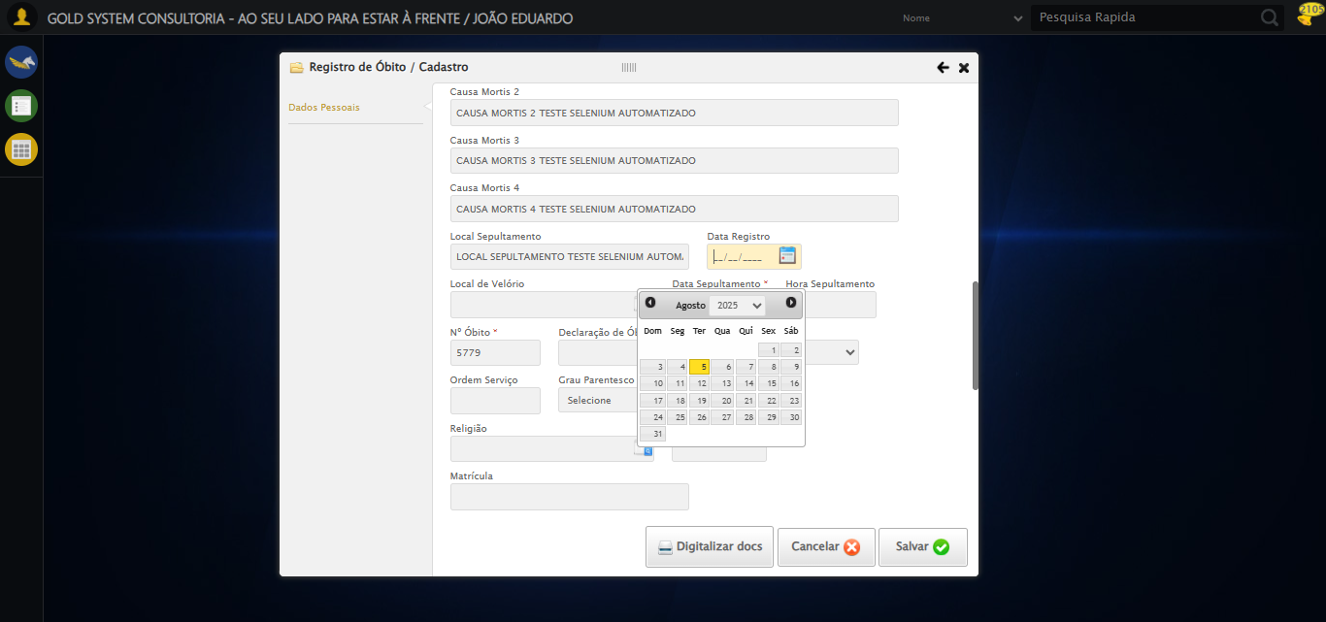

🔄 Preenchendo Data e Hora do Sepultamento...

Tentando seletor 1 para Data do Sepultamento: //input[@grupo='10036' and @ref='96']

⚠️ Seletor 1 falhou para Data do Sepultamento: Message: element click intercepted: Element <input type="text" grupo="10036" maxlength="10" id="dp1754425541571" class="hasDatepicker mandatory fc" ref="96" style="width: 90px;"> is not clickable at point (741, 313). Other element would receive the click: <select class="ui-datepicker-year" data-handler="selectYear" data-event="change">...</select>  
 (Session info: chrome=138.0.7204.184)  
Stacktrace:  
 GetHandleVerifier [0x0x30ba83+63395]  
 GetHandleVerifier [0x0x30bac4+63460]  
 (No symbol) [0x0x152113]  
 (No symbol) [0x0x1a0ba0]  
 (No symbol) [0x0x19ef5a]  
 (No symbol) [0x0x19cab7]  
 (No symbol) [0x0x19bd6d]  
 (No symbol) [0x0x190515]  
 (No symbol) [0x0x1bf3ac]  
 (No symbol) [0x0x18ffa4]  
 (No symbol) [0x0x1bf624]  
 (No symbol) [0x0x1e07ba]  
 (No symbol) [0x0x1bf1a6]  
 (No symbol) [0x0x18e7b2]  
 (No symbol) [0x0x18f654]  
 GetHandleVerifier [0x0x588883+2672035]  
 GetHandleVerifier [0x0x583cba+2652634]  
 GetHandleVerifier [0x0x332bca+223466]  
 GetHandleVerifier [0x0x322cb8+158168]  
 GetHandleVerifier [0x0x32978d+185517]  
 GetHandleVerifier [0x0x313b78+96408]  
 GetHandleVerifier [0x0x313d02+96802]  
 GetHandleVerifier [0x0x2fe90a+9770]  
 BaseThreadInitThunk [0x0x773dfcc9+25]  
 RtlGetAppContainerNamedObjectPath [0x0x77ba82ae+286]  
 RtlGetAppContainerNamedObjectPath [0x0x77ba827e+238]  
 (No symbol) [0x0]

Tentando seletor 2 para Data do Sepultamento: input[grupo='10036'][ref='96']

⚠️ Seletor 2 falhou para Data do Sepultamento: Message: element click intercepted: Element <input type="text" grupo="10036" maxlength="10" id="dp1754425541571" class="hasDatepicker mandatory fc" ref="96" style="width: 90px;"> is not clickable at point (741, 313). Other element would receive the click: <select class="ui-datepicker-year" data-handler="selectYear" data-event="change">...</select>  
 (Session info: chrome=138.0.7204.184)  
Stacktrace:  
 GetHandleVerifier [0x0x30ba83+63395]  
 GetHandleVerifier [0x0x30bac4+63460]  
 (No symbol) [0x0x152113]  
 (No symbol) [0x0x1a0ba0]  
 (No symbol) [0x0x19ef5a]  
 (No symbol) [0x0x19cab7]  
 (No symbol) [0x0x19bd6d]  
 (No symbol) [0x0x190515]  
 (No symbol) [0x0x1bf3ac]  
 (No symbol) [0x0x18ffa4]  
 (No symbol) [0x0x1bf624]  
 (No symbol) [0x0x1e07ba]  
 (No symbol) [0x0x1bf1a6]  
 (No symbol) [0x0x18e7b2]  
 (No symbol) [0x0x18f654]  
 GetHandleVerifier [0x0x588883+2672035]  
 GetHandleVerifier [0x0x583cba+2652634]  
 GetHandleVerifier [0x0x332bca+223466]  
 GetHandleVerifier [0x0x322cb8+158168]  
 GetHandleVerifier [0x0x32978d+185517]  
 GetHandleVerifier [0x0x313b78+96408]  
 GetHandleVerifier [0x0x313d02+96802]  
 GetHandleVerifier [0x0x2fe90a+9770]  
 BaseThreadInitThunk [0x0x773dfcc9+25]  
 RtlGetAppContainerNamedObjectPath [0x0x77ba82ae+286]  
 RtlGetAppContainerNamedObjectPath [0x0x77ba827e+238]  
 (No symbol) [0x0]

Tentando seletor 3 para Data do Sepultamento: #fmod_23 input[grupo='10036'][ref='96']

⚠️ Seletor 3 falhou para Data do Sepultamento: Message: element click intercepted: Element <input type="text" grupo="10036" maxlength="10" id="dp1754425541571" class="hasDatepicker mandatory fc" ref="96" style="width: 90px;"> is not clickable at point (741, 313). Other element would receive the click: <select class="ui-datepicker-year" data-handler="selectYear" data-event="change">...</select>  
 (Session info: chrome=138.0.7204.184)  
Stacktrace:  
 GetHandleVerifier [0x0x30ba83+63395]  
 GetHandleVerifier [0x0x30bac4+63460]  
 (No symbol) [0x0x152113]  
 (No symbol) [0x0x1a0ba0]  
 (No symbol) [0x0x19ef5a]  
 (No symbol) [0x0x19cab7]  
 (No symbol) [0x0x19bd6d]  
 (No symbol) [0x0x190515]  
 (No symbol) [0x0x1bf3ac]  
 (No symbol) [0x0x18ffa4]  
 (No symbol) [0x0x1bf624]  
 (No symbol) [0x0x1e07ba]  
 (No symbol) [0x0x1bf1a6]  
 (No symbol) [0x0x18e7b2]  
 (No symbol) [0x0x18f654]  
 GetHandleVerifier [0x0x588883+2672035]  
 GetHandleVerifier [0x0x583cba+2652634]  
 GetHandleVerifier [0x0x332bca+223466]  
 GetHandleVerifier [0x0x322cb8+158168]  
 GetHandleVerifier [0x0x32978d+185517]  
 GetHandleVerifier [0x0x313b78+96408]  
 GetHandleVerifier [0x0x313d02+96802]  
 GetHandleVerifier [0x0x2fe90a+9770]  
 BaseThreadInitThunk [0x0x773dfcc9+25]  
 RtlGetAppContainerNamedObjectPath [0x0x77ba82ae+286]  
 RtlGetAppContainerNamedObjectPath [0x0x77ba827e+238]  
 (No symbol) [0x0]

Tentando seletor 4 para Data do Sepultamento: //input[contains(@class, 'hasDatepicker') and @grupo='10036' and @ref='96']

⚠️ Seletor 4 falhou para Data do Sepultamento: Message: element click intercepted: Element <input type="text" grupo="10036" maxlength="10" id="dp1754425541571" class="hasDatepicker mandatory fc" ref="96" style="width: 90px;"> is not clickable at point (741, 313). Other element would receive the click: <select class="ui-datepicker-year" data-handler="selectYear" data-event="change">...</select>  
 (Session info: chrome=138.0.7204.184)  
Stacktrace:  
 GetHandleVerifier [0x0x30ba83+63395]  
 GetHandleVerifier [0x0x30bac4+63460]  
 (No symbol) [0x0x152113]  
 (No symbol) [0x0x1a0ba0]  
 (No symbol) [0x0x19ef5a]  
 (No symbol) [0x0x19cab7]  
 (No symbol) [0x0x19bd6d]  
 (No symbol) [0x0x190515]  
 (No symbol) [0x0x1bf3ac]  
 (No symbol) [0x0x18ffa4]  
 (No symbol) [0x0x1bf624]  
 (No symbol) [0x0x1e07ba]  
 (No symbol) [0x0x1bf1a6]  
 (No symbol) [0x0x18e7b2]  
 (No symbol) [0x0x18f654]  
 GetHandleVerifier [0x0x588883+2672035]  
 GetHandleVerifier [0x0x583cba+2652634]  
 GetHandleVerifier [0x0x332bca+223466]  
 GetHandleVerifier [0x0x322cb8+158168]  
 GetHandleVerifier [0x0x32978d+185517]  
 GetHandleVerifier [0x0x313b78+96408]  
 GetHandleVerifier [0x0x313d02+96802]  
 GetHandleVerifier [0x0x2fe90a+9770]  
 BaseThreadInitThunk [0x0x773dfcc9+25]  
 RtlGetAppContainerNamedObjectPath [0x0x77ba82ae+286]  
 RtlGetAppContainerNamedObjectPath [0x0x77ba827e+238]  
 (No symbol) [0x0]

❌ Erro inesperado ao preenchendo data e hora do sepultamento: Todos os seletores falharam para Data do Sepultamento. Último erro: Message: element click intercepted: Element <input type="text" grupo="10036" maxlength="10" id="dp1754425541571" class="hasDatepicker mandatory fc" ref="96" style="width: 90px;"> is not clickable at point (741, 313). Other element would receive the click: <select class="ui-datepicker-year" data-handler="selectYear" data-event="change">...</select>  
 (Session info: chrome=138.0.7204.184)  
Stacktrace:  
 GetHandleVerifier [0x0x30ba83+63395]  
 GetHandleVerifier [0x0x30bac4+63460]  
 (No symbol) [0x0x152113]  
 (No symbol) [0x0x1a0ba0]  
 (No symbol) [0x0x19ef5a]  
 (No symbol) [0x0x19cab7]  
 (No symbol) [0x0x19bd6d]  
 (No symbol) [0x0x190515]  
 (No symbol) [0x0x1bf3ac]  
 (No symbol) [0x0x18ffa4]  
 (No symbol) [0x0x1bf624]  
 (No symbol) [0x0x1e07ba]  
 (No symbol) [0x0x1bf1a6]  
 (No symbol) [0x0x18e7b2]  
 (No symbol) [0x0x18f654]  
 GetHandleVerifier [0x0x588883+2672035]  
 GetHandleVerifier [0x0x583cba+2652634]  
 GetHandleVerifier [0x0x332bca+223466]  
 GetHandleVerifier [0x0x322cb8+158168]  
 GetHandleVerifier [0x0x32978d+185517]  
 GetHandleVerifier [0x0x313b78+96408]  
 GetHandleVerifier [0x0x313d02+96802]  
 GetHandleVerifier [0x0x2fe90a+9770]  
 BaseThreadInitThunk [0x0x773dfcc9+25]  
 RtlGetAppContainerNamedObjectPath [0x0x77ba82ae+286]  
 RtlGetAppContainerNamedObjectPath [0x0x77ba827e+238]  
 (No symbol) [0x0]

Screenshot: erro_preenchendo_data_e_hora_do_sepultamento

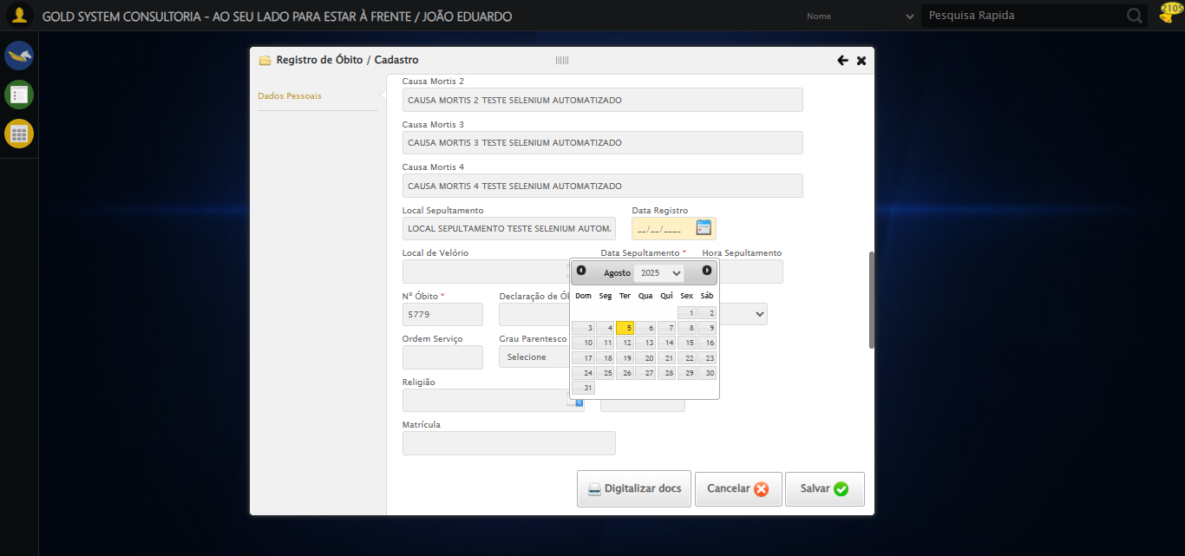

🔄 Preenchendo Declaração de Óbito...

✅ Preenchendo Declaração de Óbito realizada com sucesso.

Screenshot: preenchendo_declaração_de_óbito

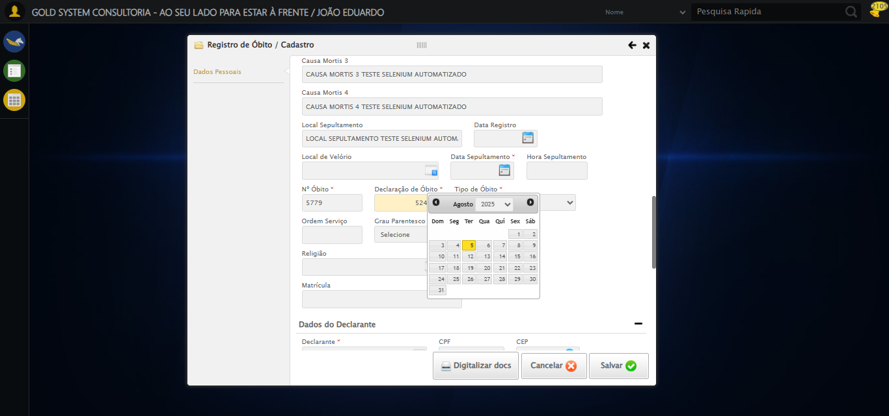

🔄 Selecionando a opção para o Tipo de Óbito ser Particular...

✅ Selecionando a opção para o Tipo de Óbito ser Particular realizada com sucesso.

Screenshot: selecionando_a_opção_para_o_tipo_de_óbito_ser_particular

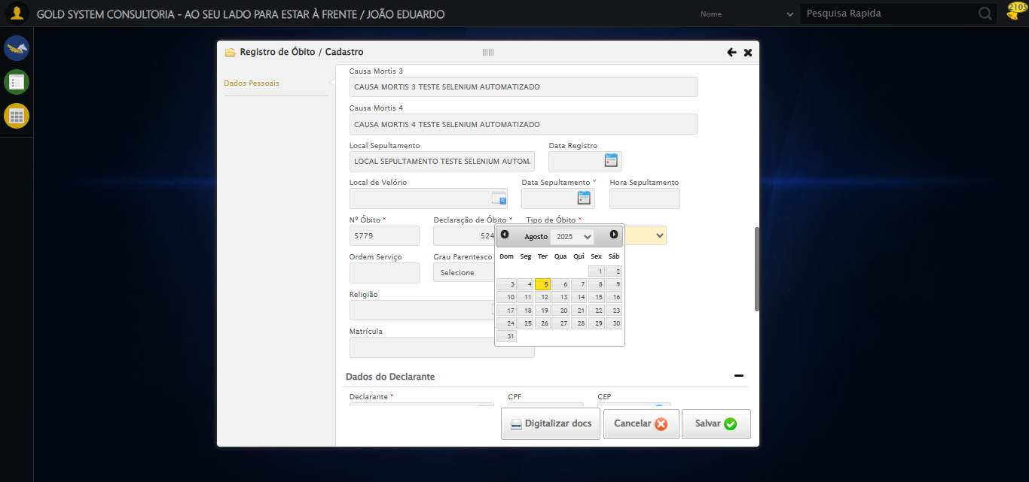

🔄 Preenchendo Ordem Serviço...

✅ Preenchendo Ordem Serviço realizada com sucesso.

Screenshot: preenchendo_ordem_serviço

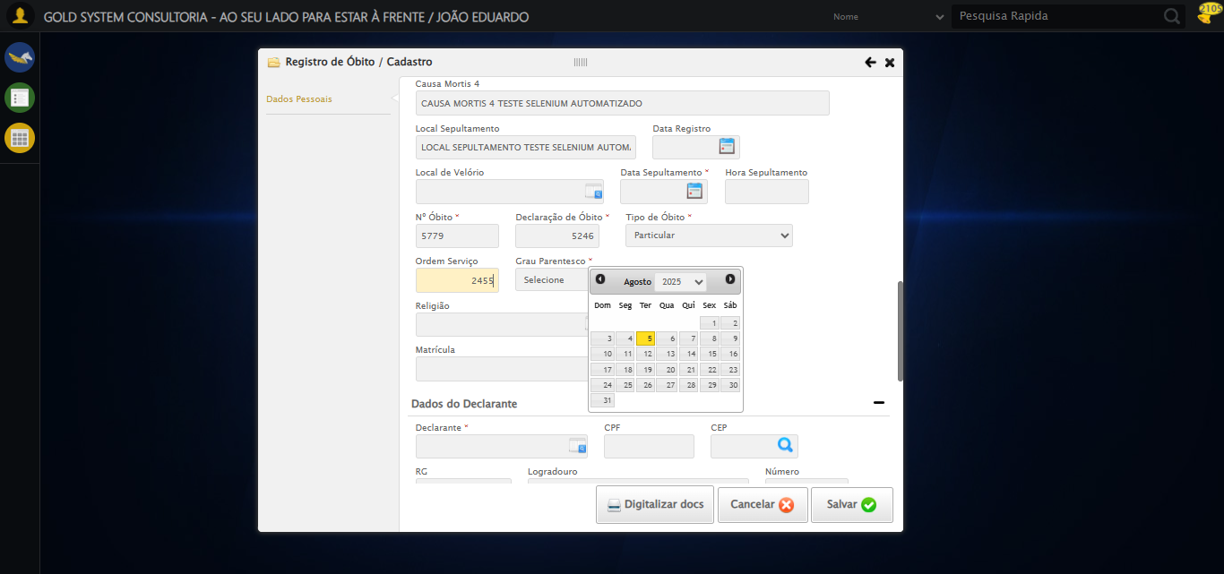

🔄 Selecionando Grau de Parentesco...

✅ Selecionando Grau de Parentesco realizada com sucesso.

Screenshot: selecionando_grau_de_parentesco

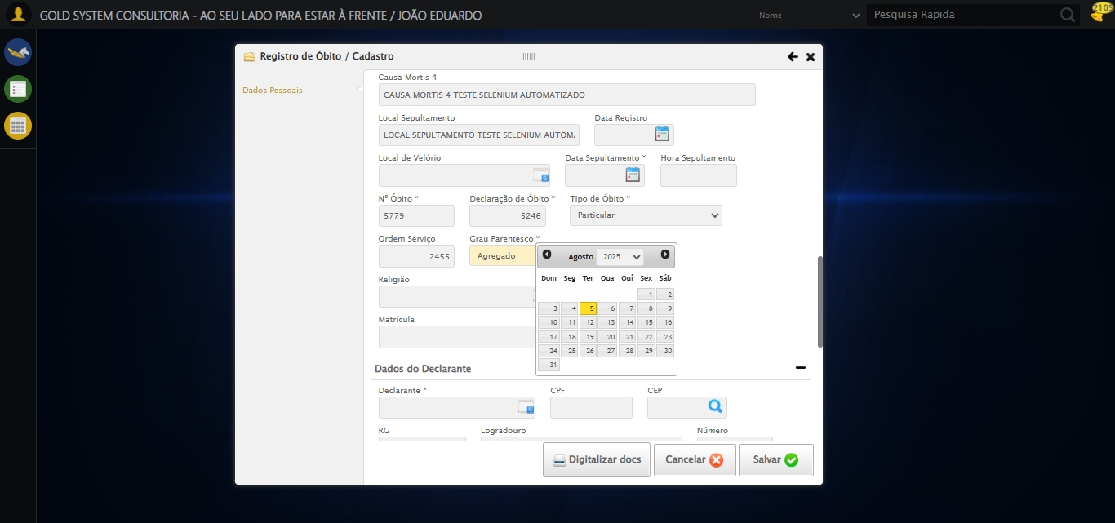

🔄 Selecionando Religião...

❌ Erro ao interagir com elemento #fmod_23 > div.wdTelas > div.telaCadastro.clearfix > div.catWrapper > div > div > div:nth-child(1) > div > div:nth-child(50) > div > a: Message: element click intercepted: Element <a class="sprites sp-openLov"></a> is not clickable at point (661, 313). Other element would receive the click: <a class="ui-datepicker-prev ui-corner-all" data-handler="prev" data-event="click" title="<Anterior">...</a>  
 (Session info: chrome=138.0.7204.184)  
Stacktrace:  
 GetHandleVerifier [0x0x30ba83+63395]  
 GetHandleVerifier [0x0x30bac4+63460]  
 (No symbol) [0x0x152113]  
 (No symbol) [0x0x1a0ba0]  
 (No symbol) [0x0x19ef5a]  
 (No symbol) [0x0x19cab7]  
 (No symbol) [0x0x19bd6d]  
 (No symbol) [0x0x190515]  
 (No symbol) [0x0x1bf3ac]  
 (No symbol) [0x0x18ffa4]  
 (No symbol) [0x0x1bf624]  
 (No symbol) [0x0x1e07ba]  
 (No symbol) [0x0x1bf1a6]  
 (No symbol) [0x0x18e7b2]  
 (No symbol) [0x0x18f654]  
 GetHandleVerifier [0x0x588883+2672035]  
 GetHandleVerifier [0x0x583cba+2652634]  
 GetHandleVerifier [0x0x332bca+223466]  
 GetHandleVerifier [0x0x322cb8+158168]  
 GetHandleVerifier [0x0x32978d+185517]  
 GetHandleVerifier [0x0x313b78+96408]  
 GetHandleVerifier [0x0x313d02+96802]  
 GetHandleVerifier [0x0x2fe90a+9770]  
 BaseThreadInitThunk [0x0x773dfcc9+25]  
 RtlGetAppContainerNamedObjectPath [0x0x77ba82ae+286]  
 RtlGetAppContainerNamedObjectPath [0x0x77ba827e+238]  
 (No symbol) [0x0]

⚠️ Tentativa 1 falhou para Selecionando Religião, tentando novamente...

🔄 Selecionando Religião... (Tentativa 2)

❌ Erro ao interagir com elemento #fmod_23 > div.wdTelas > div.telaCadastro.clearfix > div.catWrapper > div > div > div:nth-child(1) > div > div:nth-child(50) > div > a: Message: element click intercepted: Element <a class="sprites sp-openLov"></a> is not clickable at point (661, 313). Other element would receive the click: <a class="ui-datepicker-prev ui-corner-all" data-handler="prev" data-event="click" title="<Anterior">...</a>  
 (Session info: chrome=138.0.7204.184)  
Stacktrace:  
 GetHandleVerifier [0x0x30ba83+63395]  
 GetHandleVerifier [0x0x30bac4+63460]  
 (No symbol) [0x0x152113]  
 (No symbol) [0x0x1a0ba0]  
 (No symbol) [0x0x19ef5a]  
 (No symbol) [0x0x19cab7]  
 (No symbol) [0x0x19bd6d]  
 (No symbol) [0x0x190515]  
 (No symbol) [0x0x1bf3ac]  
 (No symbol) [0x0x18ffa4]  
 (No symbol) [0x0x1bf624]  
 (No symbol) [0x0x1e07ba]  
 (No symbol) [0x0x1bf1a6]  
 (No symbol) [0x0x18e7b2]  
 (No symbol) [0x0x18f654]  
 GetHandleVerifier [0x0x588883+2672035]  
 GetHandleVerifier [0x0x583cba+2652634]  
 GetHandleVerifier [0x0x332bca+223466]  
 GetHandleVerifier [0x0x322cb8+158168]  
 GetHandleVerifier [0x0x32978d+185517]  
 GetHandleVerifier [0x0x313b78+96408]  
 GetHandleVerifier [0x0x313d02+96802]  
 GetHandleVerifier [0x0x2fe90a+9770]  
 BaseThreadInitThunk [0x0x773dfcc9+25]  
 RtlGetAppContainerNamedObjectPath [0x0x77ba82ae+286]  
 RtlGetAppContainerNamedObjectPath [0x0x77ba827e+238]  
 (No symbol) [0x0]

⚠️ Tentativa 2 falhou para Selecionando Religião, tentando novamente...

🔄 Selecionando Religião... (Tentativa 3)

❌ Erro ao interagir com elemento #fmod_23 > div.wdTelas > div.telaCadastro.clearfix > div.catWrapper > div > div > div:nth-child(1) > div > div:nth-child(50) > div > a: Message: element click intercepted: Element <a class="sprites sp-openLov"></a> is not clickable at point (661, 313). Other element would receive the click: <a class="ui-datepicker-prev ui-corner-all" data-handler="prev" data-event="click" title="<Anterior">...</a>  
 (Session info: chrome=138.0.7204.184)  
Stacktrace:  
 GetHandleVerifier [0x0x30ba83+63395]  
 GetHandleVerifier [0x0x30bac4+63460]  
 (No symbol) [0x0x152113]  
 (No symbol) [0x0x1a0ba0]  
 (No symbol) [0x0x19ef5a]  
 (No symbol) [0x0x19cab7]  
 (No symbol) [0x0x19bd6d]  
 (No symbol) [0x0x190515]  
 (No symbol) [0x0x1bf3ac]  
 (No symbol) [0x0x18ffa4]  
 (No symbol) [0x0x1bf624]  
 (No symbol) [0x0x1e07ba]  
 (No symbol) [0x0x1bf1a6]  
 (No symbol) [0x0x18e7b2]  
 (No symbol) [0x0x18f654]  
 GetHandleVerifier [0x0x588883+2672035]  
 GetHandleVerifier [0x0x583cba+2652634]  
 GetHandleVerifier [0x0x332bca+223466]  
 GetHandleVerifier [0x0x322cb8+158168]  
 GetHandleVerifier [0x0x32978d+185517]  
 GetHandleVerifier [0x0x313b78+96408]  
 GetHandleVerifier [0x0x313d02+96802]  
 GetHandleVerifier [0x0x2fe90a+9770]  
 BaseThreadInitThunk [0x0x773dfcc9+25]  
 RtlGetAppContainerNamedObjectPath [0x0x77ba82ae+286]  
 RtlGetAppContainerNamedObjectPath [0x0x77ba827e+238]  
 (No symbol) [0x0]

❌ Erro ao selecionando religião após 3 tentativas: Message:   
Stacktrace:  
 GetHandleVerifier [0x0x30ba83+63395]  
 GetHandleVerifier [0x0x30bac4+63460]  
 (No symbol) [0x0x152113]  
 (No symbol) [0x0x19a85e]  
 (No symbol) [0x0x19abfb]  
 (No symbol) [0x0x1e2f92]  
 (No symbol) [0x0x1bf3f4]  
 (No symbol) [0x0x1e07ba]  
 (No symbol) [0x0x1bf1a6]  
 (No symbol) [0x0x18e7b2]  
 (No symbol) [0x0x18f654]  
 GetHandleVerifier [0x0x588883+2672035]  
 GetHandleVerifier [0x0x583cba+2652634]  
 GetHandleVerifier [0x0x332bca+223466]  
 GetHandleVerifier [0x0x322cb8+158168]  
 GetHandleVerifier [0x0x32978d+185517]  
 GetHandleVerifier [0x0x313b78+96408]  
 GetHandleVerifier [0x0x313d02+96802]  
 GetHandleVerifier [0x0x2fe90a+9770]  
 BaseThreadInitThunk [0x0x773dfcc9+25]  
 RtlGetAppContainerNamedObjectPath [0x0x77ba82ae+286]  
 RtlGetAppContainerNamedObjectPath [0x0x77ba827e+238]  
 (No symbol) [0x0]

Screenshot: erro_selecionando_religião

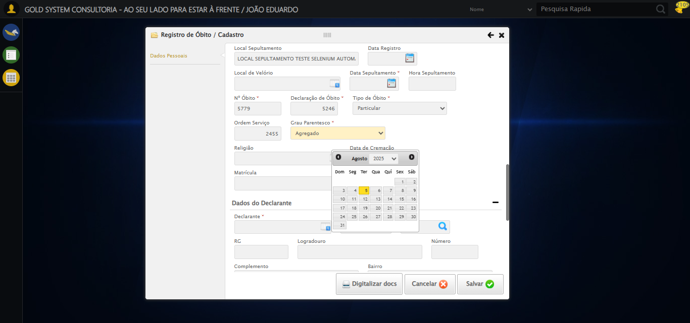

🔄 Preenchendo Matrícula...

✅ Preenchendo Matrícula realizada com sucesso.

Screenshot: preenchendo_matrícula

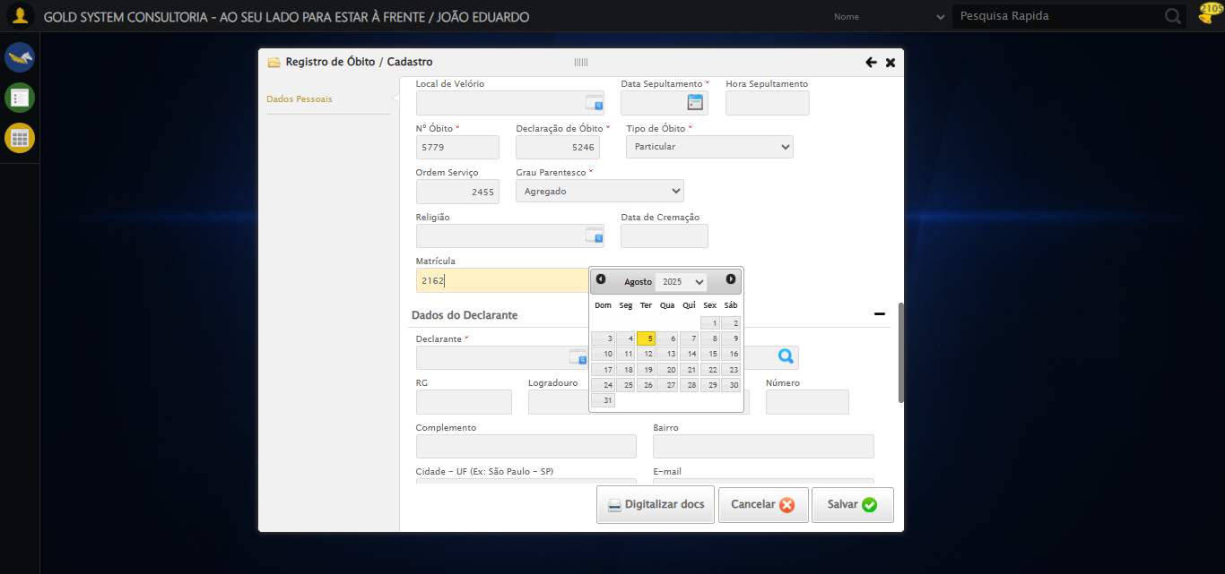

🔄 Selecionando Declarante...

✅ Selecionando Declarante realizada com sucesso.

Screenshot: selecionando_declarante

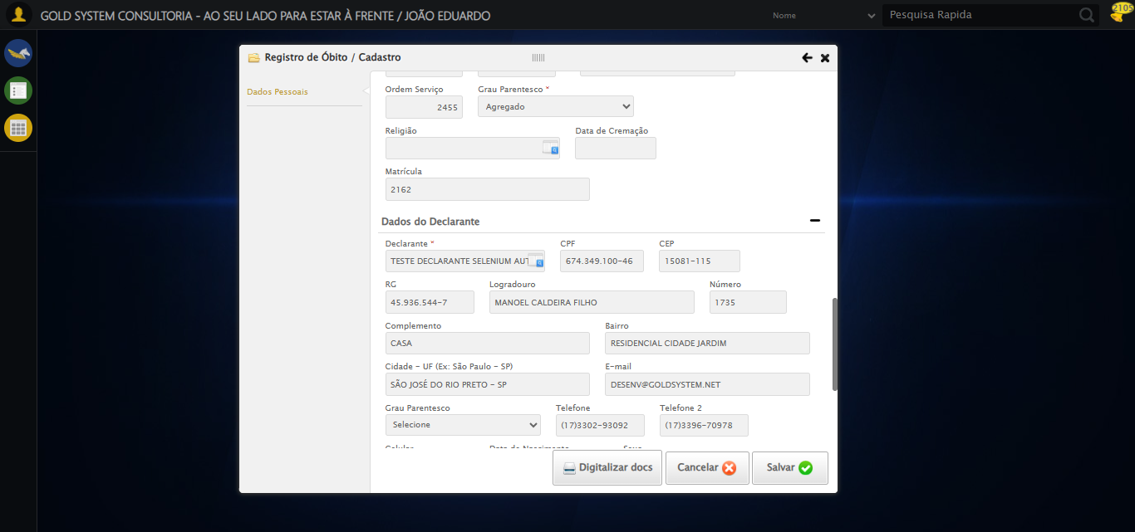

🔄 Selecionando Estado Civil...

✅ Selecionando Estado Civil realizada com sucesso.

Screenshot: selecionando_estado_civil

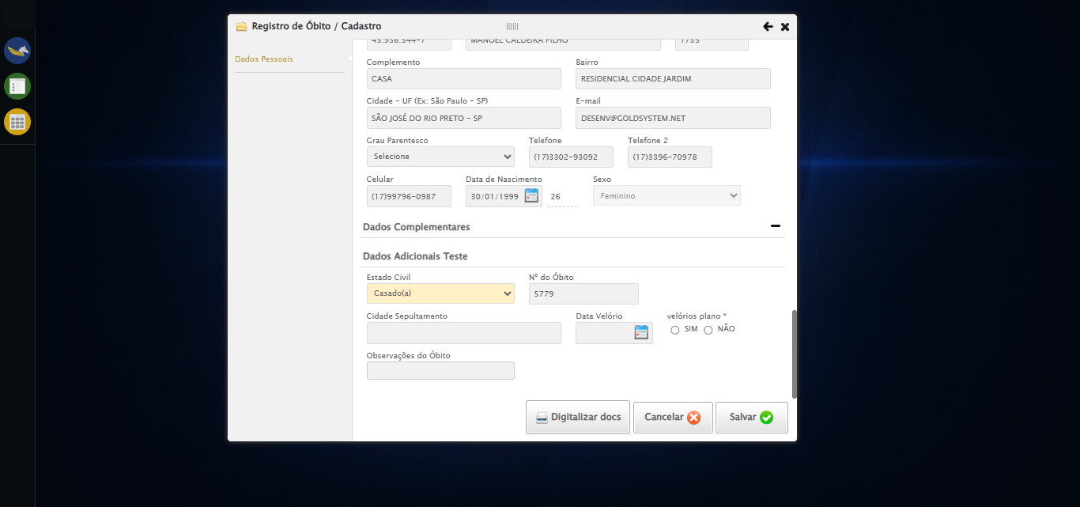

🔄 Preenchendo Cidade Sepultamento...

✅ Preenchendo Cidade Sepultamento realizada com sucesso.

Screenshot: preenchendo_cidade_sepultamento

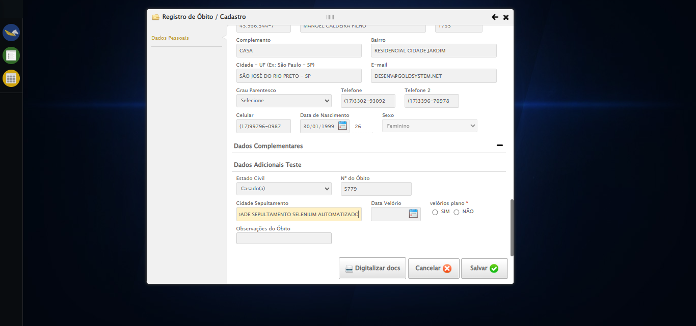

🔄 Preenchendo data do Velório...

Tentando seletor 1 para Data do Velório: //input[@grupo='100040' and @ref='100159']

⚠️ Valor não foi definido corretamente no seletor 1

Tentando seletor 2 para Data do Velório: input[grupo='100040'][ref='100159']

⚠️ Seletor 2 falhou para Data do Velório: Message: element click intercepted: Element <input type="text" grupo="100040" maxlength="10" id="dp1754425541573" class="hasDatepicker fc" ref="100159" style="width: 90px;"> is not clickable at point (777, 421). Other element would receive the click: <div class="ui-datepicker-header ui-widget-header ui-helper-clearfix ui-corner-all">...</div>  
 (Session info: chrome=138.0.7204.184)  
Stacktrace:  
 GetHandleVerifier [0x0x30ba83+63395]  
 GetHandleVerifier [0x0x30bac4+63460]  
 (No symbol) [0x0x152113]  
 (No symbol) [0x0x1a0ba0]  
 (No symbol) [0x0x19ef5a]  
 (No symbol) [0x0x19cab7]  
 (No symbol) [0x0x19bd6d]  
 (No symbol) [0x0x190515]  
 (No symbol) [0x0x1bf3ac]  
 (No symbol) [0x0x18ffa4]  
 (No symbol) [0x0x1bf624]  
 (No symbol) [0x0x1e07ba]  
 (No symbol) [0x0x1bf1a6]  
 (No symbol) [0x0x18e7b2]  
 (No symbol) [0x0x18f654]  
 GetHandleVerifier [0x0x588883+2672035]  
 GetHandleVerifier [0x0x583cba+2652634]  
 GetHandleVerifier [0x0x332bca+223466]  
 GetHandleVerifier [0x0x322cb8+158168]  
 GetHandleVerifier [0x0x32978d+185517]  
 GetHandleVerifier [0x0x313b78+96408]  
 GetHandleVerifier [0x0x313d02+96802]  
 GetHandleVerifier [0x0x2fe90a+9770]  
 BaseThreadInitThunk [0x0x773dfcc9+25]  
 RtlGetAppContainerNamedObjectPath [0x0x77ba82ae+286]  
 RtlGetAppContainerNamedObjectPath [0x0x77ba827e+238]  
 (No symbol) [0x0]

Tentando seletor 3 para Data do Velório: #fmod_23 input[grupo='100040'][ref='100159']

⚠️ Seletor 3 falhou para Data do Velório: Message: element click intercepted: Element <input type="text" grupo="100040" maxlength="10" id="dp1754425541573" class="hasDatepicker fc" ref="100159" style="width: 90px;"> is not clickable at point (777, 421). Other element would receive the click: <div class="ui-datepicker-header ui-widget-header ui-helper-clearfix ui-corner-all">...</div>  
 (Session info: chrome=138.0.7204.184)  
Stacktrace:  
 GetHandleVerifier [0x0x30ba83+63395]  
 GetHandleVerifier [0x0x30bac4+63460]  
 (No symbol) [0x0x152113]  
 (No symbol) [0x0x1a0ba0]  
 (No symbol) [0x0x19ef5a]  
 (No symbol) [0x0x19cab7]  
 (No symbol) [0x0x19bd6d]  
 (No symbol) [0x0x190515]  
 (No symbol) [0x0x1bf3ac]  
 (No symbol) [0x0x18ffa4]  
 (No symbol) [0x0x1bf624]  
 (No symbol) [0x0x1e07ba]  
 (No symbol) [0x0x1bf1a6]  
 (No symbol) [0x0x18e7b2]  
 (No symbol) [0x0x18f654]  
 GetHandleVerifier [0x0x588883+2672035]  
 GetHandleVerifier [0x0x583cba+2652634]  
 GetHandleVerifier [0x0x332bca+223466]  
 GetHandleVerifier [0x0x322cb8+158168]  
 GetHandleVerifier [0x0x32978d+185517]  
 GetHandleVerifier [0x0x313b78+96408]  
 GetHandleVerifier [0x0x313d02+96802]  
 GetHandleVerifier [0x0x2fe90a+9770]  
 BaseThreadInitThunk [0x0x773dfcc9+25]  
 RtlGetAppContainerNamedObjectPath [0x0x77ba82ae+286]  
 RtlGetAppContainerNamedObjectPath [0x0x77ba827e+238]  
 (No symbol) [0x0]

Tentando seletor 4 para Data do Velório: //input[contains(@class, 'hasDatepicker') and @grupo='100040' and @ref='100159']

⚠️ Seletor 4 falhou para Data do Velório: Message: element click intercepted: Element <input type="text" grupo="100040" maxlength="10" id="dp1754425541573" class="hasDatepicker fc" ref="100159" style="width: 90px;"> is not clickable at point (777, 421). Other element would receive the click: <div class="ui-datepicker-header ui-widget-header ui-helper-clearfix ui-corner-all">...</div>  
 (Session info: chrome=138.0.7204.184)  
Stacktrace:  
 GetHandleVerifier [0x0x30ba83+63395]  
 GetHandleVerifier [0x0x30bac4+63460]  
 (No symbol) [0x0x152113]  
 (No symbol) [0x0x1a0ba0]  
 (No symbol) [0x0x19ef5a]  
 (No symbol) [0x0x19cab7]  
 (No symbol) [0x0x19bd6d]  
 (No symbol) [0x0x190515]  
 (No symbol) [0x0x1bf3ac]  
 (No symbol) [0x0x18ffa4]  
 (No symbol) [0x0x1bf624]  
 (No symbol) [0x0x1e07ba]  
 (No symbol) [0x0x1bf1a6]  
 (No symbol) [0x0x18e7b2]  
 (No symbol) [0x0x18f654]  
 GetHandleVerifier [0x0x588883+2672035]  
 GetHandleVerifier [0x0x583cba+2652634]  
 GetHandleVerifier [0x0x332bca+223466]  
 GetHandleVerifier [0x0x322cb8+158168]  
 GetHandleVerifier [0x0x32978d+185517]  
 GetHandleVerifier [0x0x313b78+96408]  
 GetHandleVerifier [0x0x313d02+96802]  
 GetHandleVerifier [0x0x2fe90a+9770]  
 BaseThreadInitThunk [0x0x773dfcc9+25]  
 RtlGetAppContainerNamedObjectPath [0x0x77ba82ae+286]  
 RtlGetAppContainerNamedObjectPath [0x0x77ba827e+238]  
 (No symbol) [0x0]

❌ Erro inesperado ao preenchendo data do velório: Todos os seletores falharam para Data do Velório. Último erro: Message: element click intercepted: Element <input type="text" grupo="100040" maxlength="10" id="dp1754425541573" class="hasDatepicker fc" ref="100159" style="width: 90px;"> is not clickable at point (777, 421). Other element would receive the click: <div class="ui-datepicker-header ui-widget-header ui-helper-clearfix ui-corner-all">...</div>  
 (Session info: chrome=138.0.7204.184)  
Stacktrace:  
 GetHandleVerifier [0x0x30ba83+63395]  
 GetHandleVerifier [0x0x30bac4+63460]  
 (No symbol) [0x0x152113]  
 (No symbol) [0x0x1a0ba0]  
 (No symbol) [0x0x19ef5a]  
 (No symbol) [0x0x19cab7]  
 (No symbol) [0x0x19bd6d]  
 (No symbol) [0x0x190515]  
 (No symbol) [0x0x1bf3ac]  
 (No symbol) [0x0x18ffa4]  
 (No symbol) [0x0x1bf624]  
 (No symbol) [0x0x1e07ba]  
 (No symbol) [0x0x1bf1a6]  
 (No symbol) [0x0x18e7b2]  
 (No symbol) [0x0x18f654]  
 GetHandleVerifier [0x0x588883+2672035]  
 GetHandleVerifier [0x0x583cba+2652634]  
 GetHandleVerifier [0x0x332bca+223466]  
 GetHandleVerifier [0x0x322cb8+158168]  
 GetHandleVerifier [0x0x32978d+185517]  
 GetHandleVerifier [0x0x313b78+96408]  
 GetHandleVerifier [0x0x313d02+96802]  
 GetHandleVerifier [0x0x2fe90a+9770]  
 BaseThreadInitThunk [0x0x773dfcc9+25]  
 RtlGetAppContainerNamedObjectPath [0x0x77ba82ae+286]  
 RtlGetAppContainerNamedObjectPath [0x0x77ba827e+238]  
 (No symbol) [0x0]

Screenshot: erro_preenchendo_data_do_velório

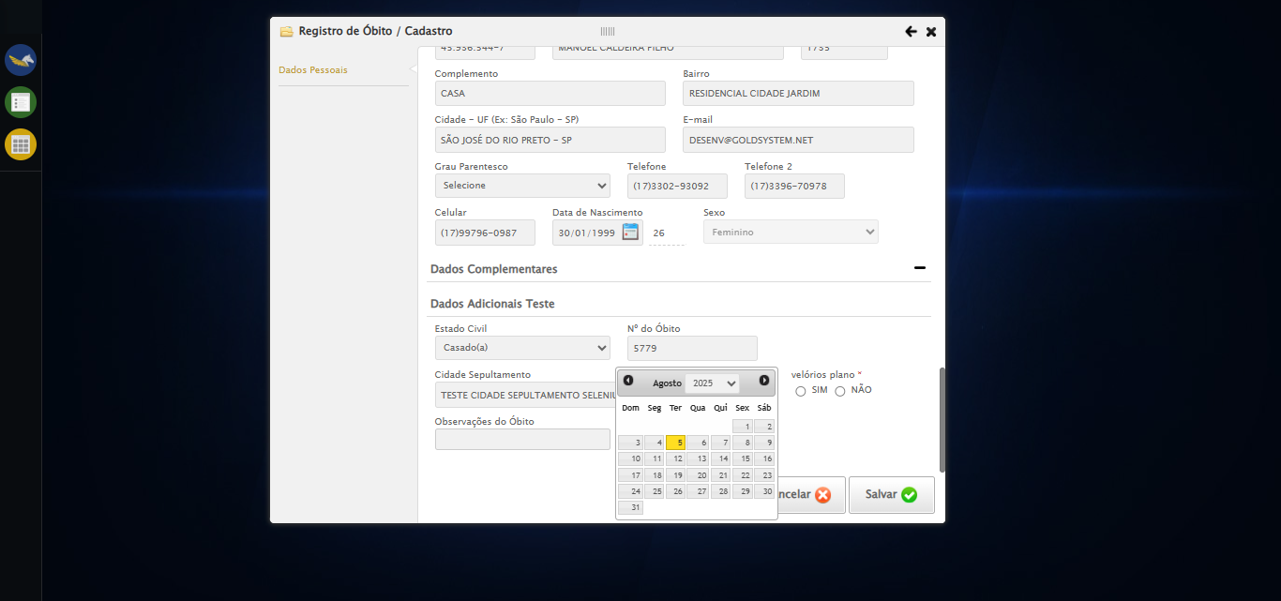

🔄 Preenchendo Observações do Óbito...

✅ Preenchendo Observações do Óbito realizada com sucesso.

Screenshot: preenchendo_observações_do_óbito

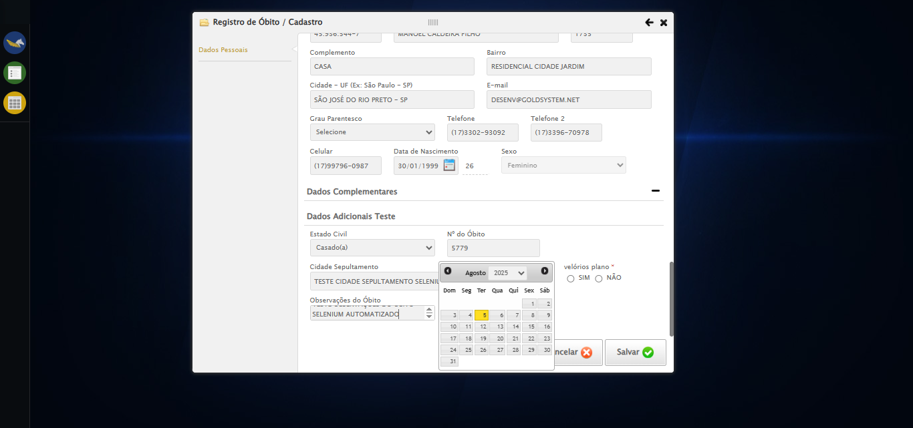

🔄 Salvando cadastro...

✅ Salvando cadastro realizada com sucesso.

Screenshot: salvando_cadastro

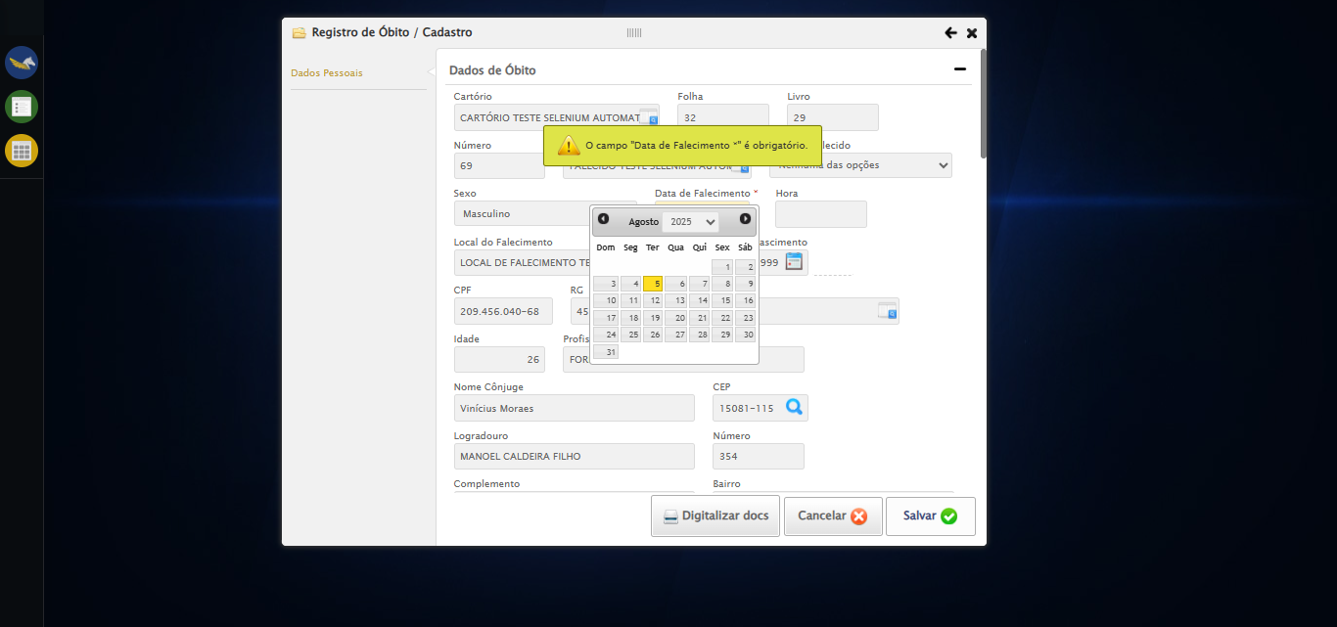

🔄 Fechando modal após o salvamento...

✅ Fechando modal após o salvamento realizada com sucesso.

Screenshot: fechando_modal_após_o_salvamento

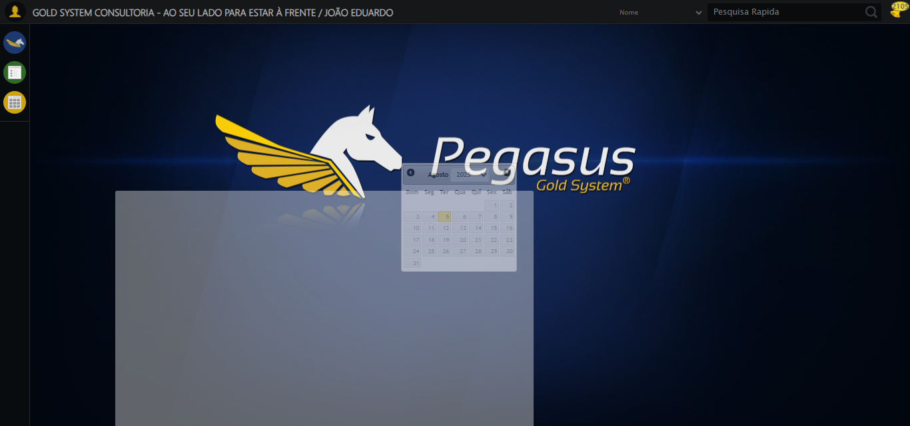

ℹ️ Nenhuma mensagem de alerta encontrada.

✅ Teste concluído com sucesso.